Epic: Documenting the use of Chaperones for Pre-op and PACU RNs

Yale New Haven Health, Yale Medicine, and Yale Health are committed to treating patients with dignity and respect. The organizations support the appropriate use of chaperones during sensitive examinations, treatments, or procedures to provide comfort and protection to patients and providers.

Chaperone Requirements

A chaperone is required for sensitive examinations, treatments, or procedures for all patients (per YNHHS policy).
- Chaperone documentation can be completed by an RN, PCA, or any staff member who has completed Chaperone training, such as a constant companion or provider.
- Patients may not opt out of the use of a Chaperone (refer to exception for Pediatric patients <13).

Documenting a Chaperone in Epic
When a chaperone is provided for a sensitive examination, treatment, or procedure, the following elements are documented in a flowsheet or in the LDA properties group:
  - The use of a chaperone
  - The chaperone’s full name and role
  - If a chaperone is not used, only for the following two reasons:
    - Medical emergency
    - Patient under 13 and parent/guardian present

Pediatric exception:
- Pediatric patients < 13 can request a parent or guardian to be present in place of a chaperone.
o Document No for Chaperone Present with a reason of Patient under 13 and parent/guardian present.
- A pediatric patient <13 can opt for a chaperone to be present in place of a parent/guardian.

LDAs:
- Ureteral catheter LDAs will include chaperone documentation rows within the properties group of the LDA. From the PreOp or Post-op Navigator:
  - Click on the Add/Edit LDAs section of the Navigator (PreOp, Post-Op)
  - Click the button
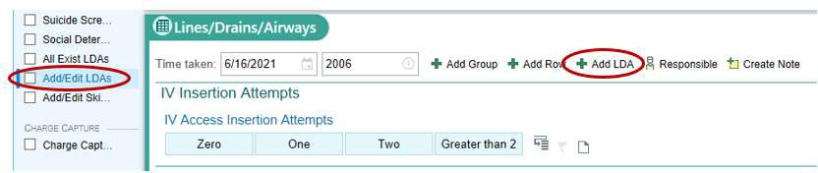

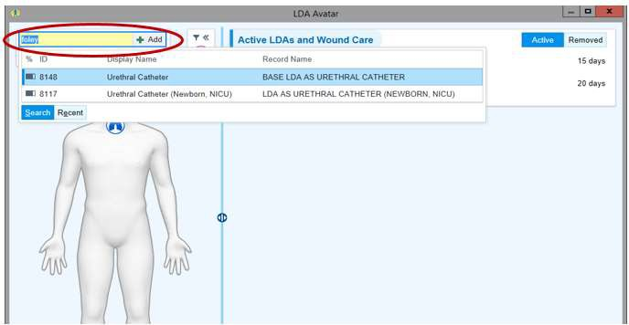
  - Enter “foley” to add the LDA (Urethral Catheter)

  - Select the body region to indicate placement of the LDA then document information about the LDA in the properties window.
  - Document chaperone rows for “Chaperone present?” or “Reason for No Chaperone” within the properties group of the LDA.

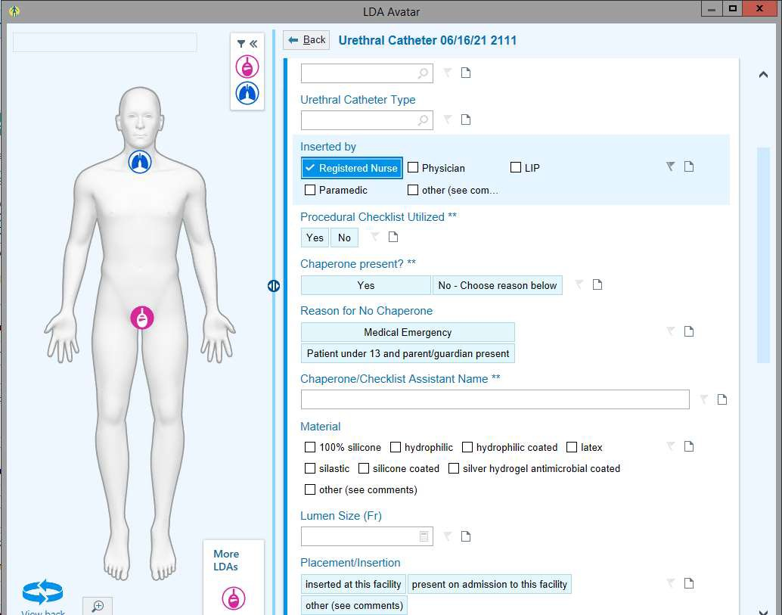
July 7, 2021– (DG)
ITS Training – OpTime Periop RNs Chaperone Documentation: ver.: 2.0

- Rectal tube LDAs will include chaperone documentation rows within the properties group of the LDA. From the PreOp PostOp Navigator:
  - Click on the Add/Edit LDAs section of the Navigator (PreOp, Post-Op)
  - Click the button
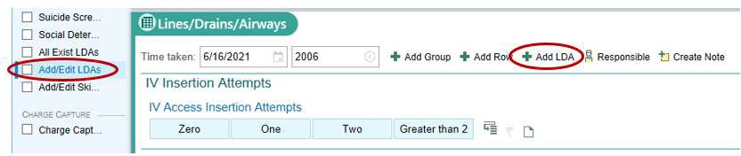

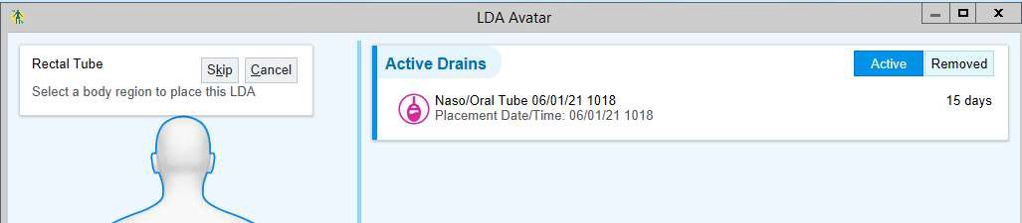
  - Enter “rectal tube” to add the LDA (Urethral Catheter).

  - Select the body region to indicate placement of the LDA then document information about the LDA in the properties window.
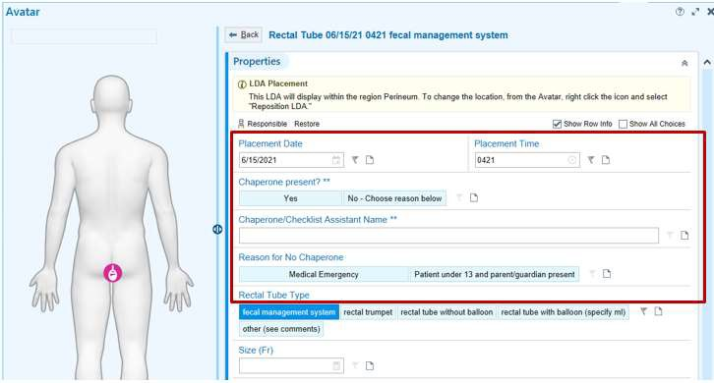
  - Document chaperone rows for “Chaperone present?” or “Reason for No Chaperone” within the properties group of the LDA.

