Timely, supportive, and transparent communication with patients is an essential component of exceptional health care. Yale Medicine (YM) recognizes that patients have the right to information of unanticipated events that have the potential to impact their health status. YM and Yale New Haven Health have collaborated to establish a program for the disclosure of adverse outcomes and events of harm, and this is referred to as CLEAR (Communication Leads to Early Resolution). The CLEAR program has trained coaches to assist you in the preparation of a disclosure conversation and requesting assistance with a CLEAR disclosure can be made anytime of the day or night. The following guidelines include many of the elements from the CLEAR program, which have been designed to assist you in communicating with patients when an adverse outcome and event of harm has occurred in either the inpatient or ambulatory settings. Families would only be included in the discussion to the extent that the patient has agreed to their participating in the discussion (can be verbal) or if they qualify as the patient’s legally authorized representative as defined under state law (see also HIPAA Policy on personal representatives, http://hipaa.yale.edu/sites/default/files/files/5038-PR.pdf.

A. General Guidelines for Disclosure
- Disclosure is a process, not a distinct event, and begins with assessing when the patient’s medical and emotional condition permits the initial discussion of an unexpected outcome or medical error.
- Serious safety events and incidents causing patient harm (refer to section F for more information) need to be disclosed.
- Disclosure of safety events that do not cause patient harm is at the discretion of the attending physician.
- Every physician is responsible for disclosing safety events for which they are personally responsible. Physicians should not disclose safety events or perceived errors made by other caregivers without involving those caregivers in the disclosure process.

Serious safety events for both inpatient and ambulatory locations must be reported to the Yale New Haven Health Legal & Risk Services Department (LRSD) by the next business day. This can be facilitated by calling (203) 688-2291 or by initiating the CLEAR disclosure process at 475-246-TALK (8255).

B. Legal & Risk Services Department (LRSD) – Available for assistance 24/7 at 203-688-2291
- Physicians should call CLEAR (475-246-TALK (8255)) or LRSD for assistance before disclosing either an inpatient or ambulatory event to a patient and/or family member, or if they have any questions about the disclosure process.
- Trained CLEAR disclosure coaches will be made available to facilitate a successful disclosure conversation by contacting 475-246-TALK (8255). To see the process flow for CLEAR, please refer to the Appendix.

C. Guidelines for Communication
1. The attending physician, who has sought guidance from CLEAR and LSRD, should speak with the patient and family as soon as the patient is medically stable enough to understand and retain the information.

Disclosure of Adverse Outcomes and Events of Harm
- Patient Relations should be included in the care team discussion, so they may provide support to the family during disclosure and post disclosure.
- When possible, this conversation should include other members of the care team, including nurses, fellows, and residents, but the responsible attending physician should lead the discussion. Thought should be given as to the size of the team present for these conversations. It is suggested that the attending physician, primary nurse and patient relations representative be present.
- The members of the care team (e.g. attending physician, resident, fellow, nurses) should meet in advance to discuss the known facts and prepare to advise the patient (or patient guardian) and, when authorized, the patient’s family.
- Prior to disclosure, the medical record should be reviewed to determine the “preferred language” for a patient’s health care discussions. If an interpreter is required/needed, they should be considered as a member of the care team and should be included in the briefing prior to disclosure.
- When initiating a conversation with the patient and/or family members, the attending physician should:
  - Acknowledge that an unanticipated outcome has occurred. Acknowledging that an error has caused harm is only done when it is certain (shown by case review) that it has occurred.
  - Apologize that there has been an unexpected clinical outcome.
  - Describe the nature of the event in a factual and compassionate manner.
  - Answer questions based upon the information that is known at the time.
  - A commitment to review the case, provide follow up information and share what is learned should be made at the initial disclosure
  - The disclosure conversation should also end with a reiteration of an apology and commitment to the patient/family of on-going relationship.
- Disclosure conversations should not include:
  - Speculation of the cause of the error. Only facts should be reported.
  - Claiming liability by saying, “I caused this problem”
  - Criticizing the care or response of other providers
  - Making excuses, being misleading, defensive or mysterious
  - Altering the medical record, or placing personal notes or comments in the record
  - Stating or implying causation or the reason why you believe the adverse outcome occurred unless causation is clear and unequivocal
- If the cause of the serious safety event is uncertain, as it usually is initially, the physician should inform the patient and/or family that further investigation is necessary, and will occur, before the exact cause will be known.
- The physician should plan to follow-up with the patient and family as to the results of any investigation undertaken and make that plan clear to the patient and family.

D. Guidelines for Documentation
- The patient’s medical record should contain a complete, accurate and factual record of pertinent clinical information related to the event and should be completed in a timely manner. The documentation should include:
  - Objective details of the event, including date, time and place (avoid hypothesizing, speculation or assignment of blame)
  - The patient’s condition immediately before the time of the event
  - Medical intervention following the event including studies ordered, therapies initiated, medications ordered and requested consultations
  - Patient’s response to medical intervention
  - Future treatment plans
  - Documentation of disclosure conversation.
- The medical record documentation regarding the disclosure discussion should include the following: a. Time, date and place of discussion
  - Names and relationships of those present at the discussion
  - Facts pertaining to the discussion of the event
  - Patient and/or family response
  - Follow-up conversations planned with the patient and/or family
- Advice from a CLEAR disclosure coach or LRSD attorney should not be documented in the medical record.
  - The chart is for communication about the care and patient’s treatment.
  - The purpose of a coaching session is to provide support and guidance for the care team.

E. Emotional Support for Care Providers
- Being involved in a serious safety event is a difficult experience for care providers.
- If anyone on the care team should need emotional support, the following resources are available:
  - For Yale staff and faculty, the Yale University Employee Assistance Program provides counseling and support services: https://your.yale.edu/work-yale/benefits/health-andwellness/employee-assistance-program
  - For Yale New Haven Health staff and for Yale Medicine physicians, the Yale New Haven Health Employee Assistance Program provides counseling and support services: https://www.achievesolutions.net/achievesolutions/en/ynhhs/Home.do
  - The Yale New Haven Health Crisis Management Intervention Team (Available to Yale New Haven Health and Yale Medicine groups):
https://vimeo.com/ynhh/review/146812496/51cd60fabe
I. For peer to peer support after experiencing a critical incident, the Crisis
Management Intervention Team can be activated by contacting YNHH security at 203-688-2500. The team consists of employees trained to standards of critical

Disclosure of Adverse Outcomes and Events of Harm
incident stress management. Team members can help fellow employees who have experienced a critical incident and/or secondary trauma stress to “debrief” – talk about their roles in and reactions to critical events.
II. The page operator at 203-688-4242 may also be contacted and request to activate the peer support team. Typically, the team can be activated within 24 hours to provide pertinent information and debriefing sessions about a critical incident. When necessary the team can be dispatched immediately.
d. The Medically Induced Trauma Support Services (MITSS), Inc., a non-profit organization “whose mission is “To Support Healing and Restore Hope” to patients, families, and clinicians who have been affected by an adverse medical event”. For faculty and staff who have been impacted by a serious safety event, MITSS offers confidential, emotional, telephone support by calling 888-366-4877. For more information about MITSS, go to http://www.mitss.org/clinicians_home.html.

F. Definitions
In 2006, Healthcare Performance Improvement (HPI) developed the Safety Event Classification (SEC) and the Serious Safety Event Rate (SSER). “The Safety Event Classification provides common definitions and an algorithm for the classification of safety events. The classification is based on the degree of harm that results from a deviation from expected performance or standard of care. The SEC serves as the foundation for the calculation of the Serious Safety Event Rate, a volume-adjusted measure of events resulting in moderate to severe harm, including death. Together, the SEC and SSER provide a consistent methodology for measuring patient harm and improvement in reducing patient harm. Over 100 hospitals across the United States are using the SEC and SSER.”

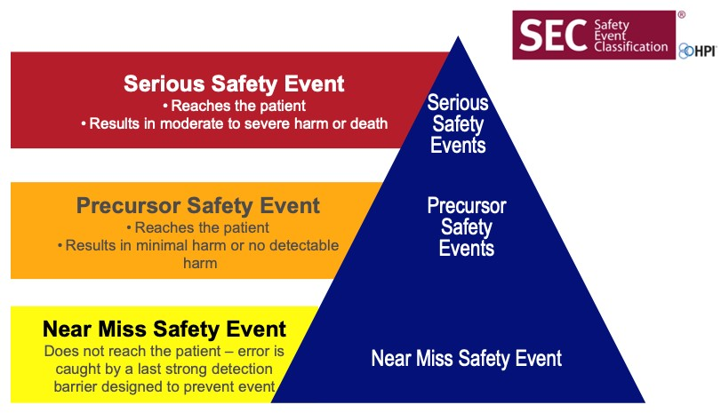

Appendix: Example of YNHHS CLEAR Disclosure Process
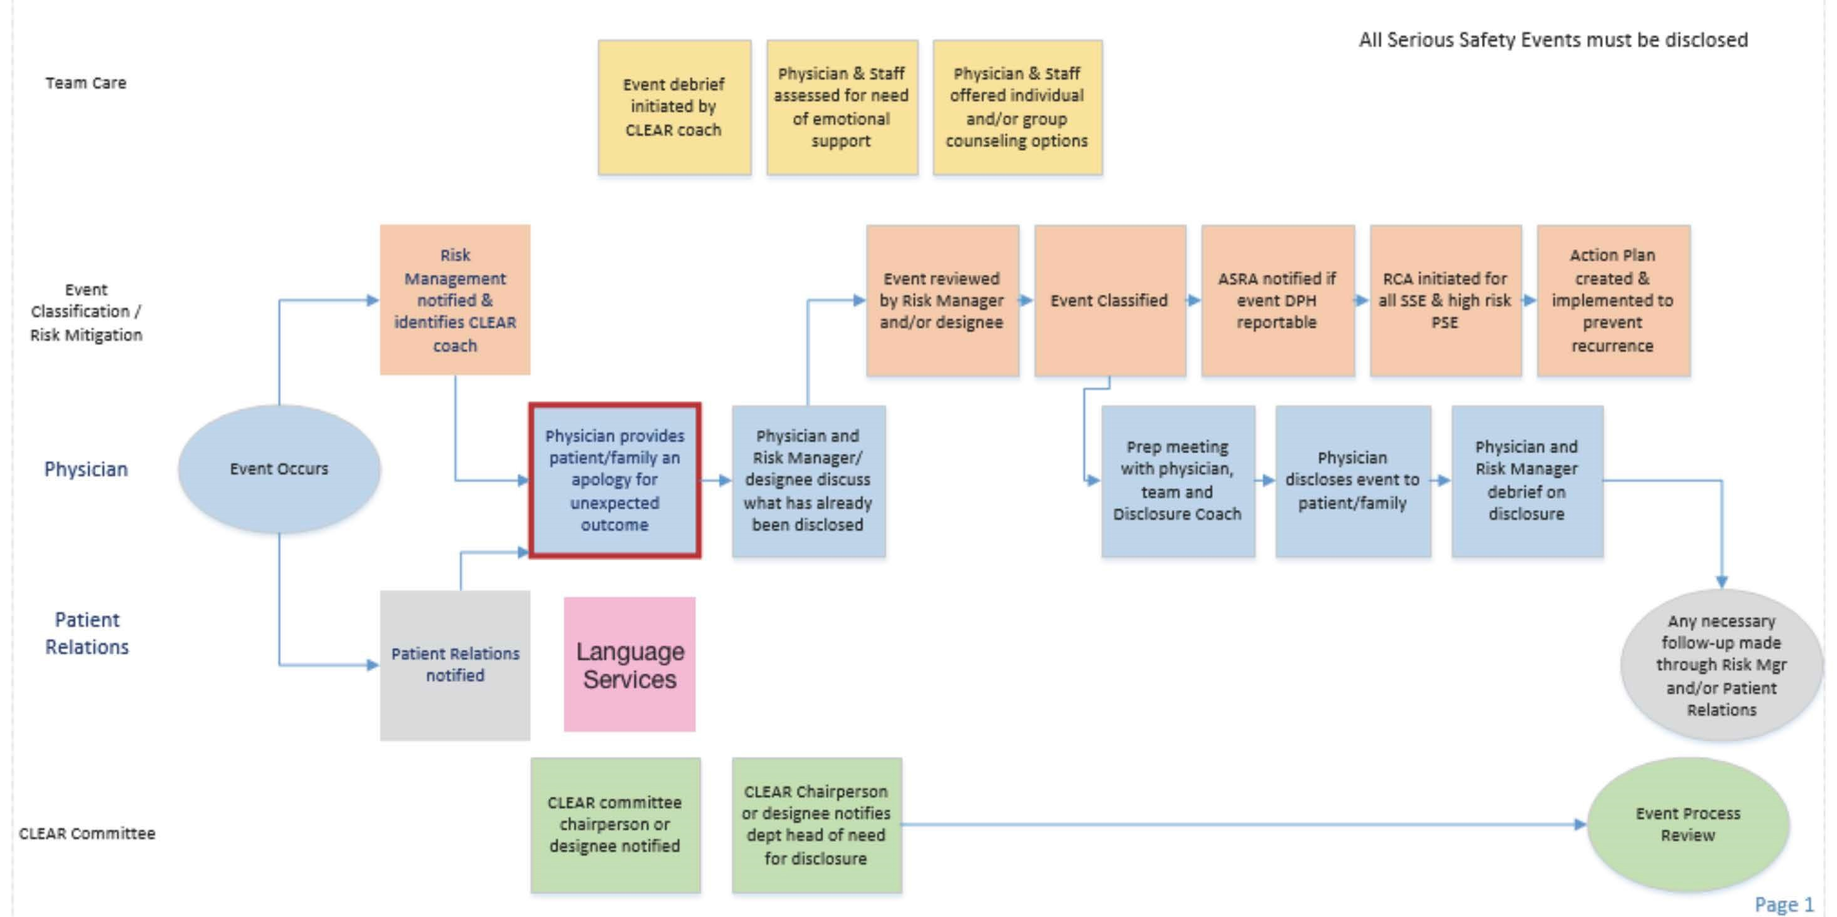

CLEAR DISCLOSURE ASSISTANCE CALL
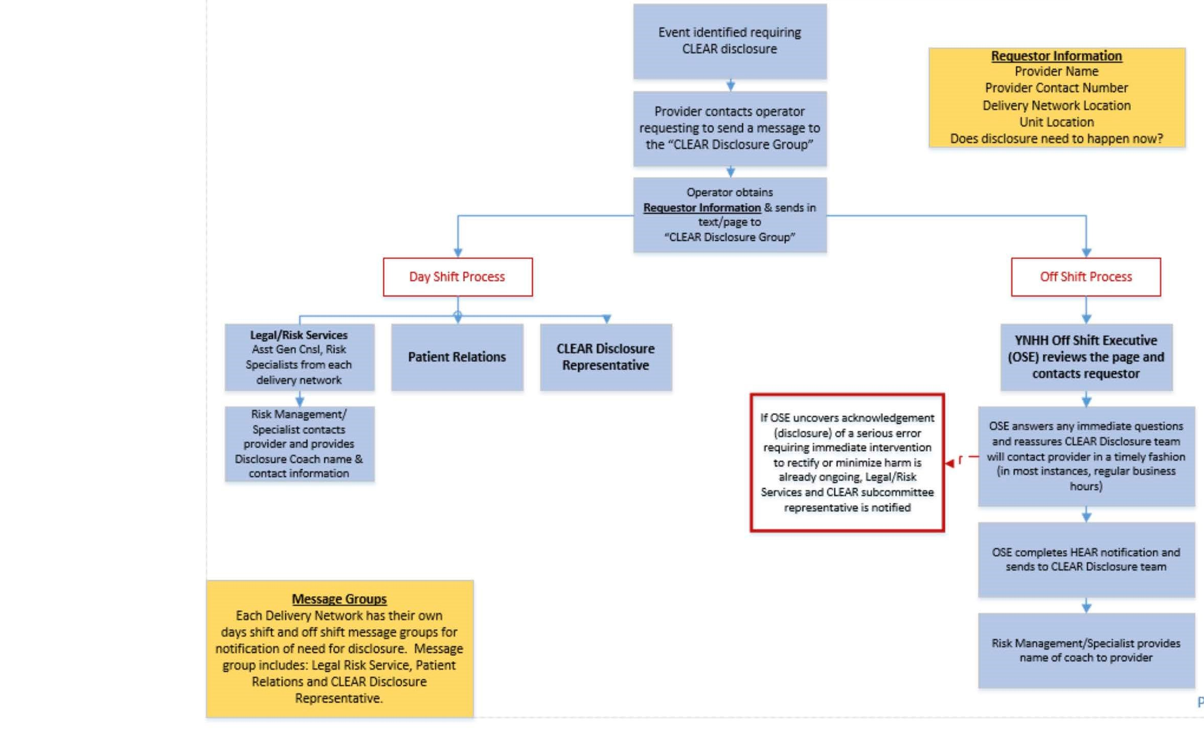

Health Performance Improvement (HPI), SEC & SSER Patient Safety Measurement System for Healthcare, HPI White Paper Series - Revision 2, May 2011, https://www.pressganey.com/docs/default-source/default-document-library/hpi-white-paper---sec-amp-sser-measurement-system-rev-2-may-2011.pdf?sfvrsn=0.

