The APS tab is used for APS accounts funded both by Division/Department funds as well as Endowment/Gift funds. To determine which APS tab to use (APS 92020 or APS 44006) run a detailed transaction report on your APS account and then a pivot table off of the results by ledger account. The funding ledger account will drive which tab to use
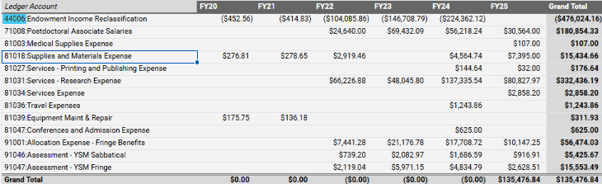
*If your APS account is funded by multiple ledger’s, choose the tab based on the largest funding source and then there will be some manual steps along the way to account for both funding sources.
- Make a copy of the APS tab (keep one as an original with all the formulas). Right click on the APS tab, choose the Move or Copy option, click the ‘Create a copy’ box and choose a location in the workbook for the tab. Then click OK.
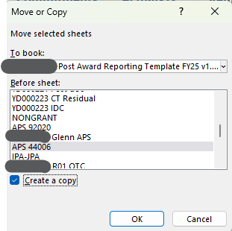

- Rename the new APS tab to be associated with the account that will be captured on this tab (example YD235 Startup).

- Use the drop-down box in cell B7 to select the COA for your account. This drop-down box will only display the COAs you have setup on Data tab in the NonGrant section. Once you select the COA the tool will bring in all the information that was entered in the Data tab and it will automatically bring in the non-personnel inception to date actuals in column G from the Raw Data/Actuals tab.
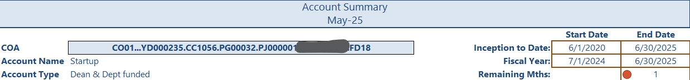
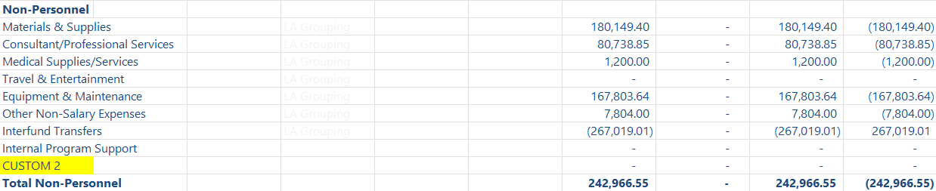

- To bring in the Personnel expenses you must select each person who has been or is being paid from this account in the Personnel section starting in row 212. Using the drop-down blue boxes select the individuals who have been paid from the account. The annual salary from the Data tab will automatically be pulled in.

  - Enter the effort amount into column D and use the formula “=J9” in column E to have the Remaining Mths based on the calculated remaining project months shown in cell J9. You can also choose to manually key this amount but then you will need to manually update every month.
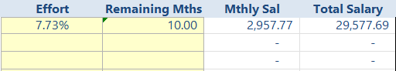
  - Next select the appropriate fringe rate from the drop-down box in column H and enter any comments about the encumbrance period in column L.
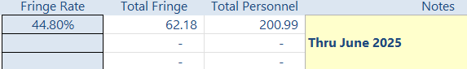
  - The expenses to date, plus commitments for future months should be displayed under the Direct Cost/Personnel Salary and Fringe sections starting in row 39.
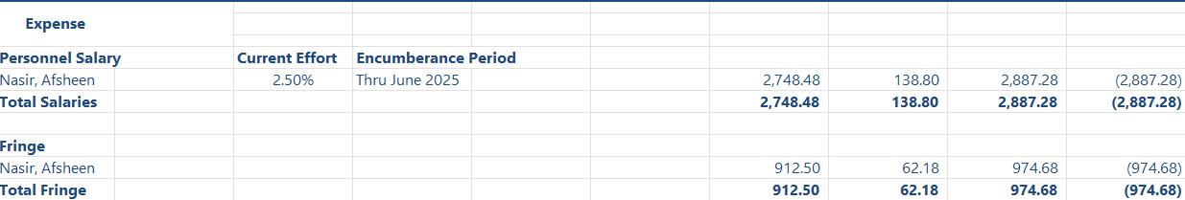
  - If there are individuals who are being hired on the account but haven’t had salary hit yet you will need to enter their name and appointment/salary information on the Data tab first in the yellow cells that have MANUAL--> next to them.
Then on the APS tab select their name from the drop-down yellow box (starting in row 392) and follow steps a – c shown above.
  - If this is the only person supported on the project and you don’t want to see the extra lines you can select rows 40-41, then go to the Data option in the ribbon up top and click on the Group option to the far right.
You will see a vertical line appear to the left of these rows. Click on the and the rows will now be hidden.
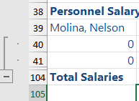
If you need to add additional personnel on the project you can expand this section by clicking on the , highlighting the row(s) you need to see, going to the Data option in the ribbon and clicking on the Ungroup option. These expansions & retraction options are throughout the workbook and can be utilized by clicking on the and as needed.
- Revenue: On the APS tab, external revenue (department/division) will pull into the top portion of the page, where internal revenue will pull into the Non-Personnel section of your expenses under the line “Interfund Transfers”
  - You need to make sure that your inception date on the data tab goes back far enough to capture the appropriate revenue transfers.
External Revenue Section: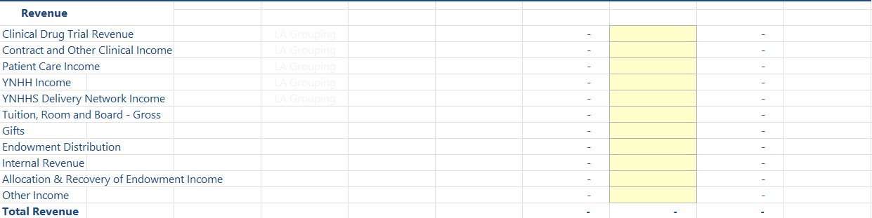
Internal Revenue Section:
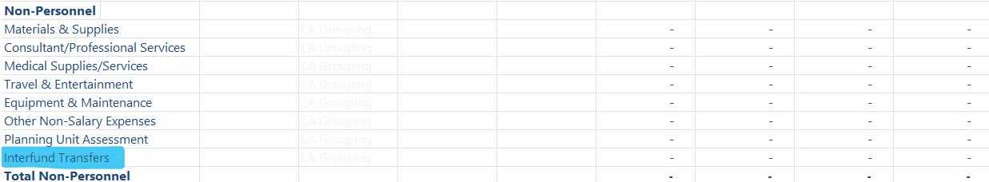
  - If you have an APS account that is funded from two external sources you could use the following workaround. Edit one of the external revenue lines to align with your second source of external funding.
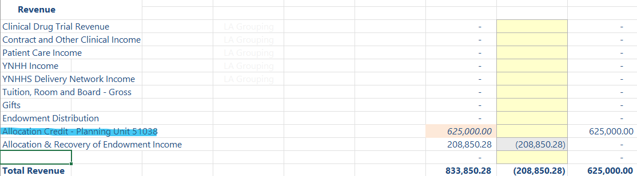
  - Manually enter the amount shown in your detailed transaction pivot table. Suggest that you somehow draw attention to this number (highlight/italics) so you have a visual reminder that this number needs to be manually updated monthly.
  - If you want to display your interfund transfers in the Revenue section up top you can edit another line to be “Total Fund Transfers” (and then delete the words “Interfund Transfers” in the line in the expense section). You will need to edit the formula in column G to add a “*-1” at the end to show this amount as a positive.
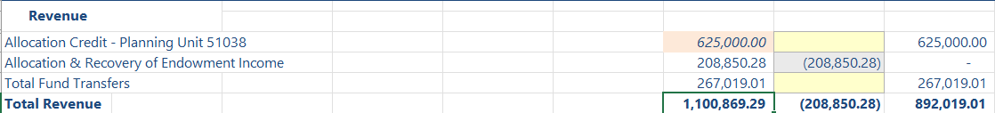
  - Enter your promised startup funds in cell N16 (Initial Startup Package).
  - If your APS account is funded from a single source no additional steps are needed for your revenue section.
  - If your APS account is funded from multiple sources you will need to adjust the formulas in column H accordingly.
For example this account is funded 50% from 51038 and 50% from a mix of 44006 and interfund transfers. The original startup package was $1,250,000.
The formula in the commitment column next to the $625,000 would be “N16/2-G29”. Original commitment divided by 2 and then reduced by funds that have been provided to date.
The formula in the commitment column next to $208,850.28 would be “(N16/2)-G30-G31”. Original commitment divided by 2 and then reduced by funds provided to date from 44006 and interfund transfers.
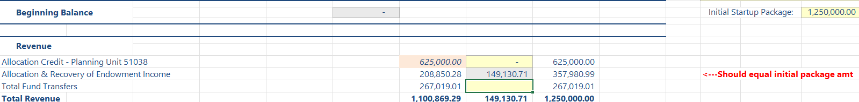
- Run the Account Balances Detail in Workday. Make sure to run the report for the period that aligns with the period your Power BI data download was for. Use the ‘Current Period YTD’ time period option
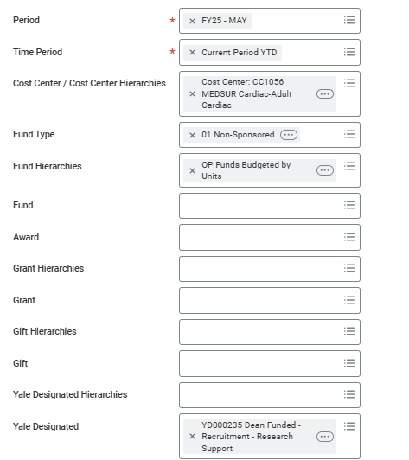

Enter the Ending Balance amount in cell H208.
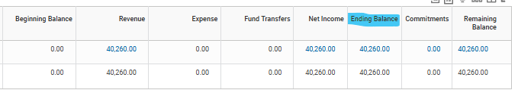

The amount displayed in cell I208 should now be zero.

If I208 does not show a zero-dollar balance:
Run a detailed transaction on the account in Workday for the time period it was active.
Download the report to excel and run a pivot table using the following:
Rows: Ledger Account Grouping & Employee
Values: Sum of Amount of Natural Debit/Credit
Compare the totals shown in your Pivot table to the tab in your report to find the difference.

- Pending non-personnel commitments can be entered in the sections starting with row 413 by spend category. These can be actual known commitments, or you can use an average based on the past 6 months activity, which is then multiplied by the remaining project months. Any commitments entered will be shown in the APS Summary section above.
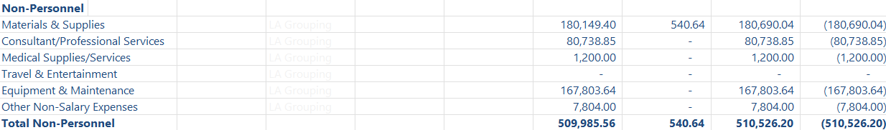
- Use the notes section in cell L2 to capture important information about the account.
- Below the commitment section in cell A877 includes a snip picture of the original APS letter or any other information that is necessary for the management of the funds.

Reference
Standardized Planning Model (SPM)/Projection Tool - Clinical - Reference

Contact Information
- YSM Controller’s Office: ysmcontroller@yale.edu

Version History
- 10/10/2025: New user guide

Keywords
post, award, reporting, aps tab, user, guide, reference
Responsible Official: Associate Controller, Yale School of Medicine
Document Administrator: Kelsey Schieren
Date of Origin: 10/10/2025
Approval Date: 10/13/2025

The official version of this information will only be maintained in an on-line web format. Any and all printed copies of this material are dated as of the print date. Please make certain to review the material on-line prior to placing reliance on a dated printed version.

