YSM Department Space Manager Role
- A Department Space Manager (DSM) can submit updates to occupancy in any location where they are identified as a contact on one or more occupying organizations in that location.
- Access is based on the Allocated Group; users only have access to update spaces allocated to their Department. However, users are able to select occupying employees (Faculty only) within and outside of their Departments.
- Single Room Updates (SRUs) created by DSMs must be forwarded to a YSM Space Manager (Mariah Priest) for approval who will review and forward the request to the University Space Manager for approval into AssetWorks.
- Log in:
https://yale.assetworks.cloud/ready/
- Click Single Room Update icon:
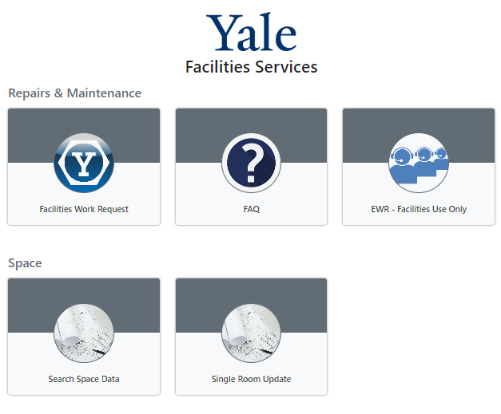
Enter search criteria on either the “Search for Properties” tab or the “Search for Locations” tab to find the location occupancy to be updated.  The Property Field requires either the 4 digit building code or the building name written using specific syntax. The 4 digit building codes are provided on the Space Dashboard (first 4 digits of the External ID) and on the Space Dashboard Helpful Information file (“Buildings” Tab).  Click Search  Click on the 4 digit property code (ie 2970).  Click on the number of rooms available for the floor you want to update (ie 121). | 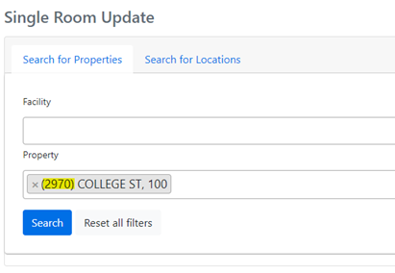  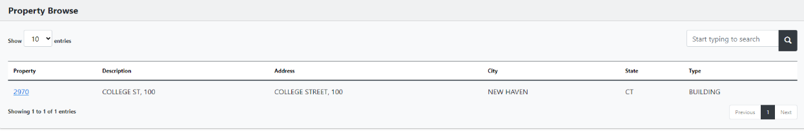  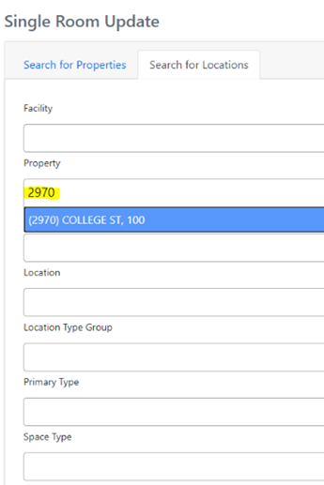  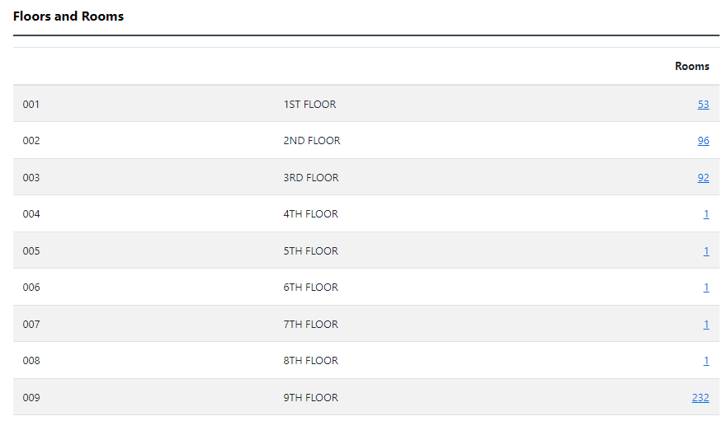
On Room(s) Listing Screen click a Location to view Occupancy. Can Search for room in upper right of the screen. | 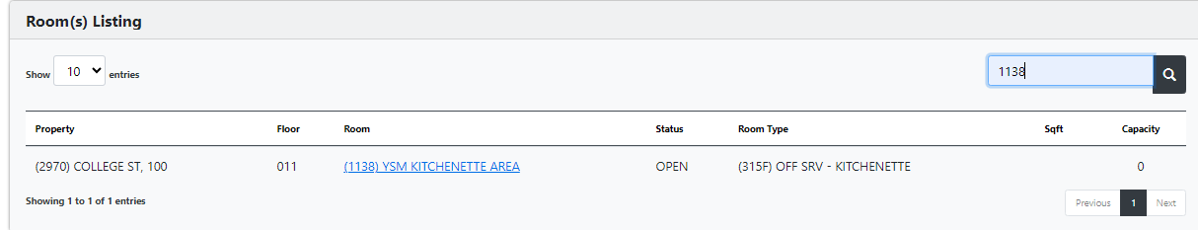
View Location Facts | 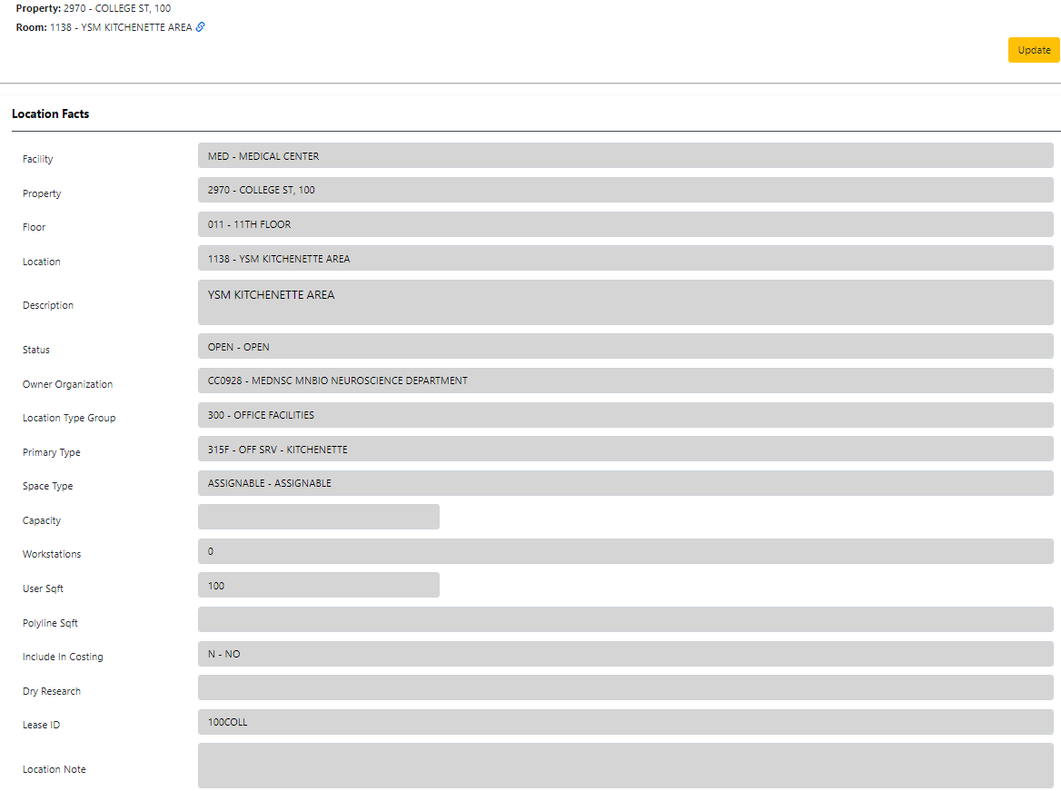
View Organization Occupancy, Usage and Employee Occupancy | 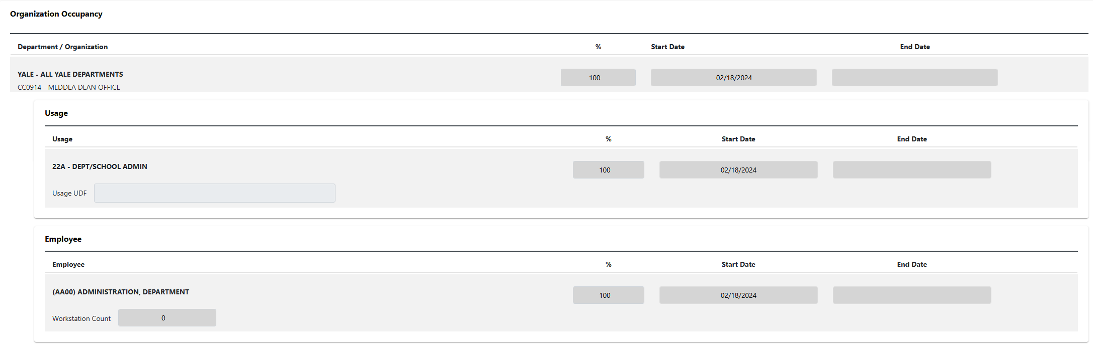
Access Authorization  Access is limited to authorized cost centers only.  If the DSM is not a contact on any of the Occupying Organizations in the location, a warning message will display.  DSMs will only see and be able to update the occupancy for the organization they are the contact for. Other occupancies will be “disabled”.  DSM is NOT a contact for CC0914  DSM is a contact for CC0928 | 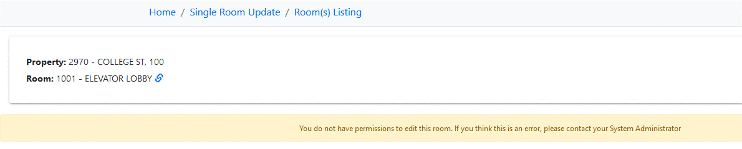  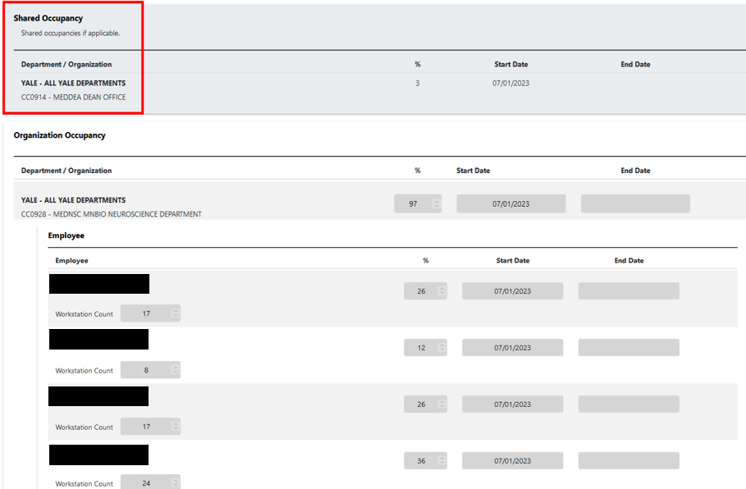
How to Update  Click Update to begin creating an update request. | 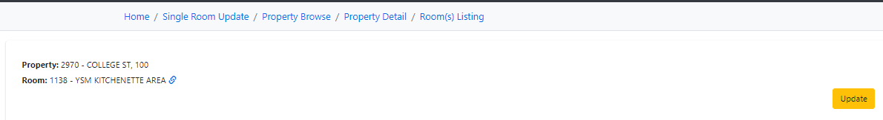
Location Note Required  Enter a brief note in the Location Note field to describe update requested.  Updates to room description, primary type, owner organization, capacity or workstations must be noted in the Location Note field for the University Space Manager to update.  Dry Research updates can be selected from the drop down menu options. | 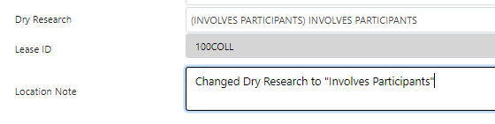
Edit Organization  End Date current Organization, Usage and Employee(s).  Click Add and a new section appears below. Select new Organization, Enter % % (ensure Organization section(s) total = 100%) and Start Date the day after the previous Organization was ended.  Ensure there are no gaps between end date of prior record and start date of new record. System will not allow a gap in dates.  Do not update Usage. This section should remain blank as it is maintained by YSM centrally.  Add in Employee(s) – See Edit Employee section for details. | 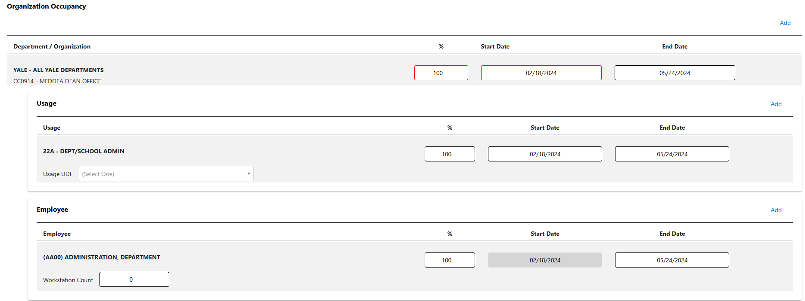
Edit Employee  End Date any employee line that is changing (ie. workstation counts, removing employee(s), percentage changes).  Click Add and a new section appears below. Select Employee. Individual employee updates are only for Faculty. Staff are entered as “Department Administration”. If the room is vacant for Faculty use “Future Faculty” or “Designated Faculty” and for staff use “Future Admin”. Enter workstations (wet labs only), % (ensure Employee section(s) total = 100%) and Start Date the day after the previous Employee was ended.  Ensure there are no gaps between end date of prior record and start date of new record. System will not allow a gap in dates. | 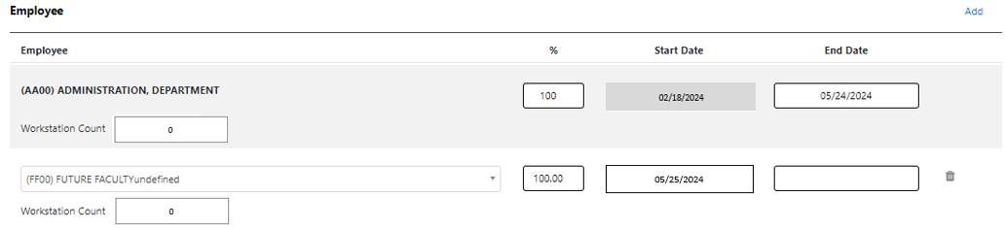
Submit or Cancel  Click Submit to save or Cancel to withdraw your update request.  Submitted requests “lock” the location until the pending request has either been Canceled by the DSM, Canceled by the YSM Space Manager or Approved/Rejected by the University Space Manager.  Note: Once you click “Submit”, the request is not yet sent to the YSM Space Manager for processing. You must submit the request in the Process tab after a final review. See Process Tab - Review and Submit  for details. | 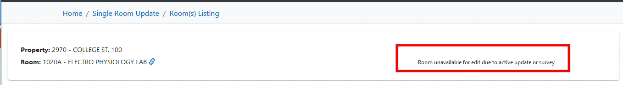  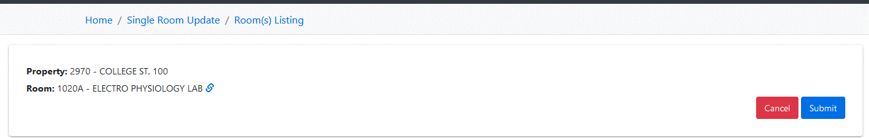
Process Tab - Review and Submit

Click Process on the menu bar and then click Review under Space to view requests awaiting verification.

A side-by-side view of the original information and the submitted changes is provided for a final review.

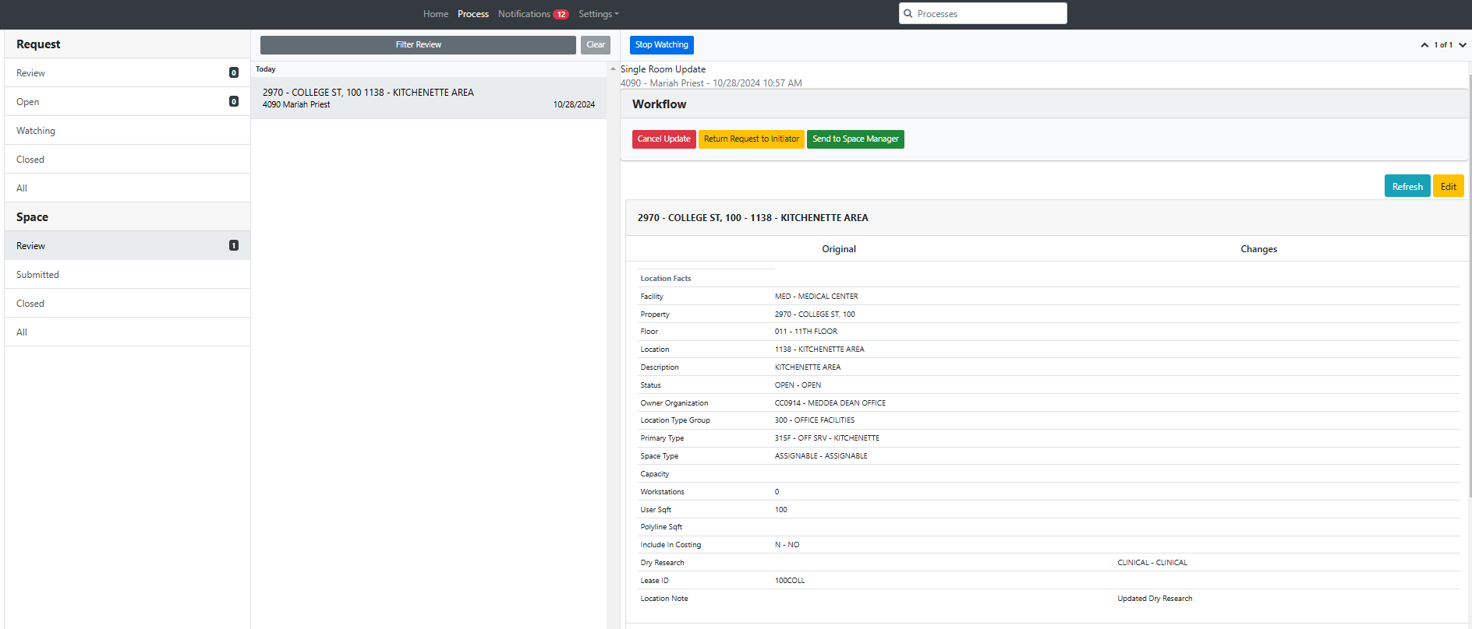
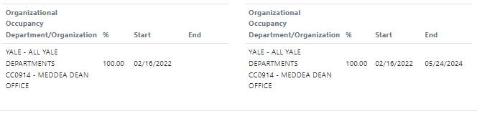
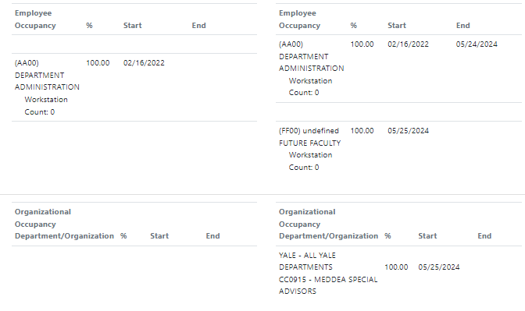
Review the changes and if they appear to be correct, click “Send to Space Manager” to submit update request for processing. You may also Edit or Cancel Update if needed.

Note: Clicking Edit will open the request in a new browser tab. Make the necessary edits and click Save. Close this tab and click Refresh in the Process tab to view the updated request.

Submitted  Requests sent to the YSM Space Manager move to Submitted. | 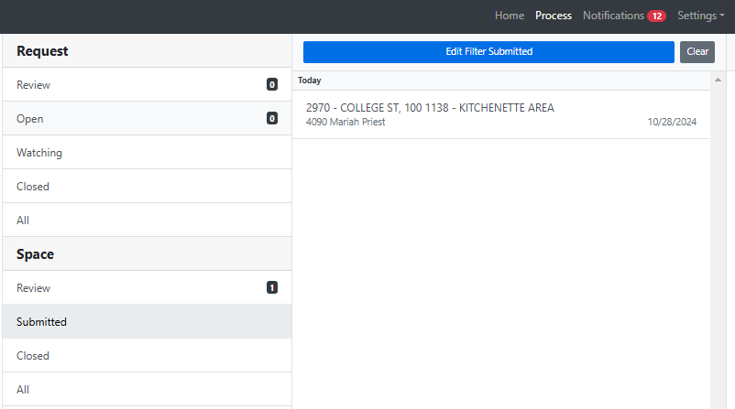
Closed  Requests canceled by the DSM, canceled by the YSM Space Manager or approved/rejected by the University Space Manager move to Closed. | 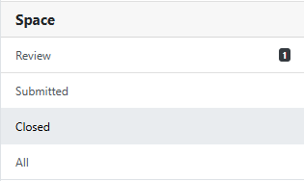
Status Updates  At the very bottom of each request is an indicator of where the request is in the “Workflow”. | Request waiting for the DSM to forward to the YSM Space Manager:  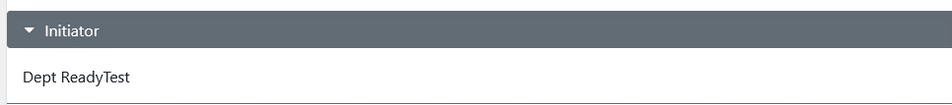  Request waiting for YSM Space Manager to forward to Space Manger:  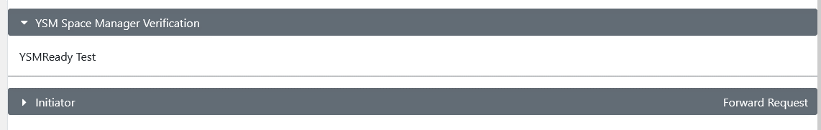  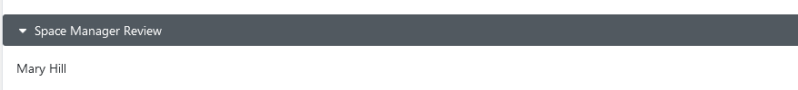  Requests awaiting University Space Manager approval:
Comments  Comments can be entered in the comment block at the bottom of each request and are visible to all users involved in the processing of a request. If a request is returned to you, a comment will be left describing the reason. You must press Enter to log a comment or it will not save. | 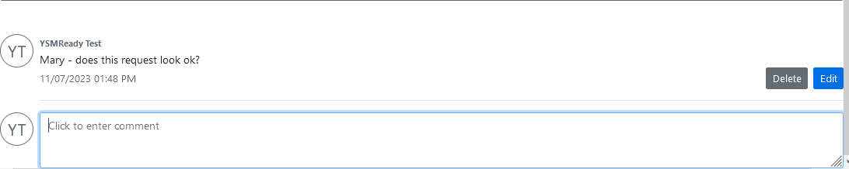
User Notifications  Users have the option to receive email notifications by checking the types they’d like to receive.  For example, if user prefers to receive an email when comments are added to a request, checking the Comments box will enable this functionality.  Similarly, checking the Task Assignment box will enable email notifications when assigned a task, e.g. when requests are returned by Space Managers. | 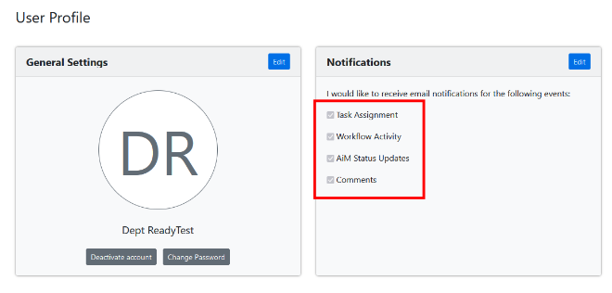  Comments example:  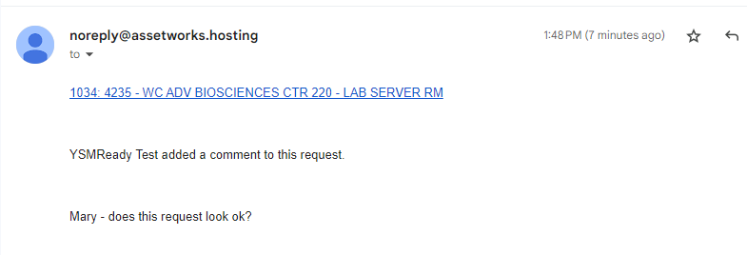  Task Assignment example:  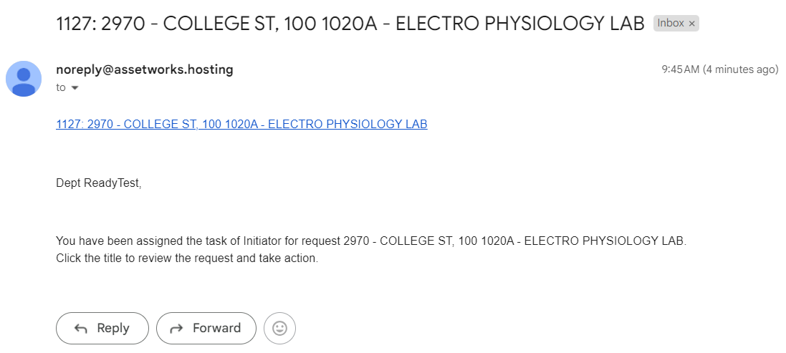

Contact Information
- YSM Director of Financial Planning & Analysis: andy.pels@yale.edu
- YSM Assistant Director of Financial Planning & Analysis: trinity.kiley@yale.edu
- YSM Financial Analyst, Financial Planning & Analysis: mariah.priest@yale.edu

Related information
YSM Space Data Review – Policy
YSM Space Data Review – Procedure

References
Yale AssetWorks
YSM AssetWorks Single Room Update Quick Guide - Reference
YSM Space Dashboard – Power BI
Helpful Info.xlsx

Version History
- 07/18/2024: New reference document

Keywords
Assetworks, Space, Room

Responsible Official: Associate Controller, Yale School of Medicine
Document Administrator: Kelsey Schieren
Date of Origin: 07/17/2024
Approval Date: 07/18/2024

The official version of this information will only be maintained in an on-line web format. Any and all printed copies of this material are dated as of the print date. Please make certain to review the material on-line prior to placing reliance on a dated printed version.

