Yale Post Award Reporting
- Updating Annual Salaries
  - To update your personnel annual salaries at beginning of the new fiscal year navigate to your Data tab.
  - Copy the current FYXX (in this example FY25) column salaries (Highlight and then Ctrl C)
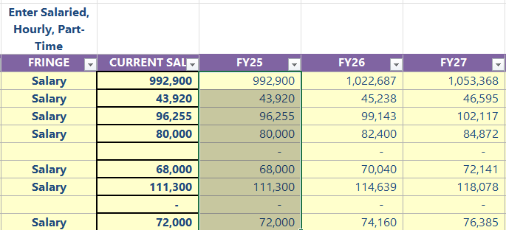
  - Then paste the values as text in the same cells (right click and choose the Paste Option )

  - Manually enter your new FY salaries into the Current Salaries column (column H)
  - Adjust the formula in the actual current FYXX column (in this example it would be FY26 which is column J) to be “=[@[CURRENT SAL]]” in cell J455 and then drag that formula down to the pertinent cells for the Personnel in column J.

Reference
Standardized Planning Model (SPM)/Projection Tool - Clinical - Reference

Contact Information
- YSM Controller’s Office: ysmcontroller@yale.edu

Version History
- 10/10/2025: New user guide

Keywords
post, award, reporting, updating annual salaries, reference

Responsible Official: Associate Controller, Yale School of Medicine
Document Administrator: Kelsey Schieren
Date of Origin: 10/10/2025
Approval Date: 10/13/2025

The official version of this information will only be maintained in an on-line web format. Any and all printed copies of this material are dated as of the print date. Please make certain to review the material on-line prior to placing reliance on a dated printed version.

