Sections
- Ambulatory Services – Exhibit 10100.EX. A Ambulatory Services

For the system (Epic) to automatically generate charges from EpicCare ambulatory module to the Charge Router, the provider must perform a step called closing the encounter. Closing the clinical encounter tells the system to send the charge information from EpicCare to the Charge Router and on to professional billing. If the provider does not perform this step, the system does not send charge information through the Charge Router to professional billing.

- Accessing the Open Encounters JDAT Report

To identify these Open Encounters, compile the JDAT report through the BI Portal that captures patient encounters open beyond 3 days – “Patient Encounter Metrics – Encounters Open Beyond 3 days”. This report updates late Sunday/early Monday of each week. The recommendation would be to run the report weekly on Monday (no later than Tuesday) to capture most current data and provider activity
  - Accessing the BI Portal, select
- Documents tab – Folder – Public Folders
      - Ambulatory Clinic Documents
      - Physician KPI
      - Patient Encounter Metrics – Encounters Open Beyond 3 Days
  - Select the appropriate parameters values for your report – Epic Service Area Name – YNHHS and YM
  - Provider Entity Name – YM
  - Clinical Department Name
  - Clinical Section Name – if desired to report only this specific level
  - Other options available (but recommended for clinical department use) include:
- Clinical Subspeciality Name
- Department Building
- Department Floor
- Epic Department Name
- Provider Name
  - Be sure to select OK at each update and refresh the report for current data.
- Exporting Open Encounters JDAT Report
This report will return multiple columns of data (and will contain PHI). It is recommended that you export the report tab (Open Encounter Details) as an Excel file type(.xls). This will allow you to filter, sort, etc – and forward critical information to the providers to resolve their Open Encounters.

Columns include:
- Visit Provider Clinical Department
- Visit Provider Clinical Section
- Visit Provider Clinical Subspeciality
- Visit Provider Name
- Visit Provider NPI
- Epic Department Name
- Patient Name
- Patient MRN
- Epic Encounter CSN
- Date of Encounter
- Days Open (excludes weekends)
- Visit Type
- Encounter Type
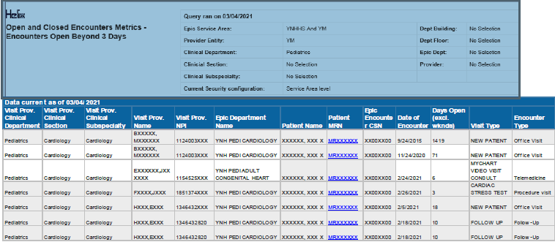
Note – as the report only updates at the beginning of the week, you cannot run it on Friday to get updated information on provider activity since Monday; it is recommended that you run the report the same day each week and provide the information to those providers that need to resolve Open Encounters.

Contact Information
Teresa Carty teresa.carty@Yale.edu
Diana MacLennan diana.maclennan@yale.edu

Version History
03/11/2022 - reference

Keywords
Open Encounters
EpicCare ambulatory module
Charge Router

Responsible Official: Senior Director, Revenue Cycle
Document Administrator: Claudia Meyers
Date of Origin: 03/04/2021
Approval Date: 04/30/2026

The official version of this information will only be maintained in an on-line web format. Any and all printed copies of this material are dated as of the print date. Please make certain to review the material on-line prior to placing reliance on a dated printed version.

