Epic
Chaperones for Exams, Treatments or Procedures in Ambulatory
Yale New Haven Health, Yale Medicine, and Yale Health are committed to treating patients with dignity and respect. The organizations support the appropriate use of chaperones during sensitive examinations, treatments, or procedures to provide comfort and protection to patients and providers.

Chaperone Requirements

A chaperone is required for sensitive examinations, treatments or procedures for all patients (per YNHHS policy).
- Chaperone documentation can be completed by an RN, PCA or any staff member who has completed Chaperone training, such as a constant companion or provider.
- Patients may not opt out of the use of a Chaperone (refer to exception for Pediatric patients <13).

Document a Chaperone in Epic
When a chaperone is provided for a sensitive examination, treatment or procedure, the following elements are documented in the Chaperone section of the Rooming Activity tab:
- The use of a chaperone
- The chaperone’s full name and role
- If a chaperone is not used (only for the following two reasons):
  - Medical emergency
  - Patient is age 13 and parent/guardian is present
- From the Rooming Activity tab, click Chaperone.

Click Yes, sensitive parts of the examination were performed with chaperone present speed button.
- 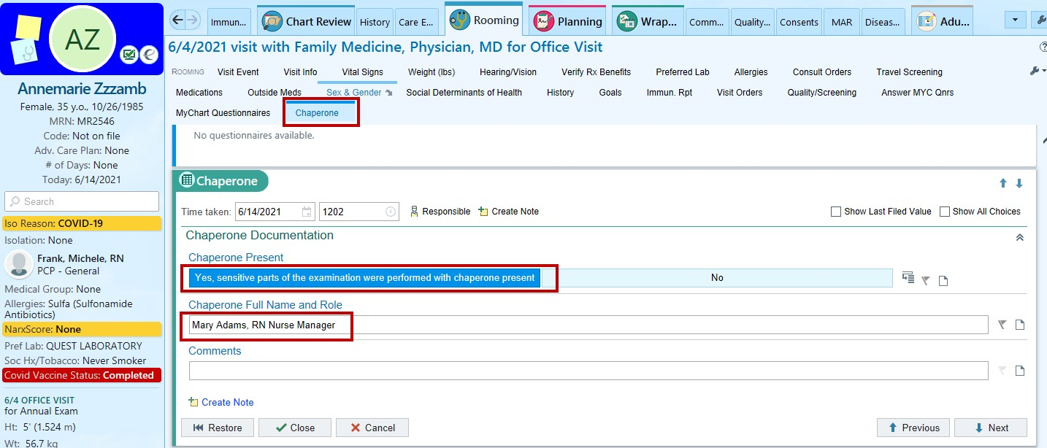Type the chaperone’s Full Name and Role.

If No Chaperone Present
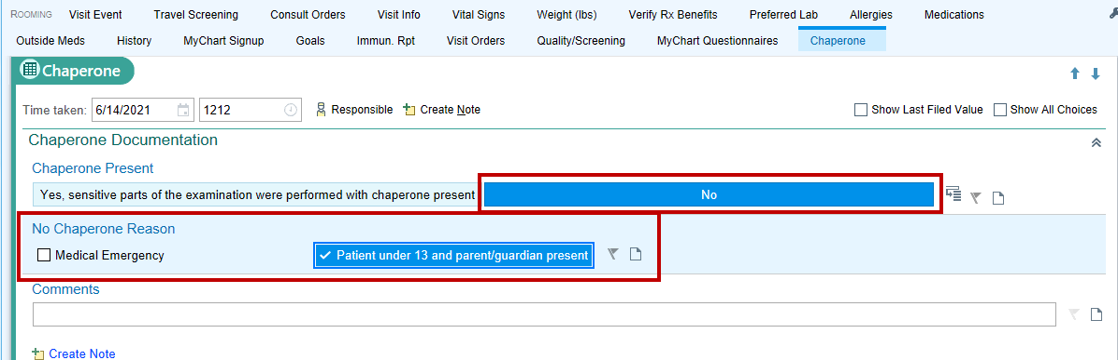1. Click No and select either Medical Emergency or Patient under 13 and parent/guardian present.

ITS Training – EpicCare Ambulatory v2020 – Chaperones for Exams, Treatments or Procedures updated June 2021 – AIG

