Scope
This document addresses the guidelines for Yale School of Medicine (YSM) department business offices (DBO) regarding receipt of special funds from Yale New Haven Health System (YNHHS).

Guideline Purpose
The purpose of this memorandum is to document Frequently Asked Questions (FAQs) surrounding the YNHHS special funds process.

Definitions
Special Funds
Income that is received by YSM from YNHHS that is categorized as donor restricted at YNHHS (i.e., gift funds used to cover specific expenditures that meet donor restrictions) and not included in the monthly shared service invoice from YSM to YNHHS.

Guideline Sections
- Current Background
As noted in Section 3., a process update was communicated by the YSM Controller’s Office (YSMCO) to YSM Lead Administrators and Finance & Administration (F&A) Managers in December 2022 regarding changes to the assessment associated with income from YNHHS’s special funds pool. Subsequent to the issuance of that communication, DBOs have made various inquiries to the YSMCO regarding this topic. This guideline was developed in response to those inquiries.
- FAQs for specifically identified IBO Issues
  - DBO Issue: Travel is required by a YSM faculty member on behalf of YNHHS; therefore, as the YSM faculty is attending on behalf of YNHHS, and YNHHS has agreed to cover the cost, the department should not absorb the assessment.
    - YSMCO Recommendation: If YNHHS is paying for something very specific, such as in the aforementioned scenario, that is not gift-like, the YSMCO recommends that the DBO complete a YSM Non-Sponsored Assessment Reduction or Waiver Request form for review and approval by the Deputy Dean, YSM Finance & Administration.
  - DBO Issue: The DBO makes annual requests from a significant special fund gift at YNHHS. There is a documented agreement and budget, where the Yale University assessment of 12% is included. Are there any other items that the DBO should consider?
    - YSMCO Recommendation: As the existing written agreement includes the 12% assessment, when the agreement/budget is renewed each year, the department should confirm with YNHHS that it will continue to cover the assessment, as the decision is at the discretion of YNHHS.
  - DBO Issue: YNHHS places the burden of processing certain expenditures on the university. The department should not be assessed for a payment from YNHHS when it covers a “reimbursement” for an expense it refuses to pay out of its primary (i.e., non-special funds) cost center.
    - For example, YNHHS would not allow a direct purchase of equipment from a special funds account. The faculty member purchased the equipment with his personal credit card. The expense report was processed. The DBO allocated the cost to the faculty member’s discretionary account and then requested reimbursement from YNHHS. The reimbursement was approved and received; however, there was an assessment charge ultimately reducing the faculty member’s discretionary account.
    - The DBO was able to purchase supplies from Yale’s stockroom, on behalf of YNHHS, that were unavailable through vendors. When reimbursed, the department was charged an assessment fee.
    - The DBO processes expense reports for faculty members for their costs related to YNHHS. These costs are, then, reimbursed to the department with an assessment fee. To provide a service to YSM’s faculty, the DBO is charged an assessment and not receiving a full cost recovery.
      - YSMCO Recommendation: If special funds income is received to fund a specific item, such as equipment, or are for reimbursements that could have been paid by YNHHS, the YSMCO recommends that the DBO complete a YSM Non-Sponsored Assessment Reduction or Waiver Request form for review and approval by the Deputy Dean, YSM Finance & Administration.
  - DBO Issue: A program at YNHHS is interested in supporting the department through donations to certain programs. The funds are not direct YNHHS funds but are raised through fund raising activities throughout the year, including an annual gala.
    - YSMCO Recommendation: As the funds appeared to be passed through YNHHS, acting as an agent, the YSMCO recommends that the DBO complete a YSM Non-Sponsored Assessment Reduction or Waiver Request form for review and approval by the Deputy Dean, YSM Finance & Administration.
  - DBO Issue: The department utilizes the YNHHS gift funds for various expenses, and YNHHS has agreed to fund the operational deficits of the department. Historically, when the request for the amount needed is made, a gross-up is included within the billing. Should this continue?
    - YSMCO Recommendation: If YNHH agrees to continue to allow the grossed-up billings, the DBO may continue in that manner. Ultimately, whether it is agreed upon at the time of billing or at the time the full operational deficit is covered, a negotiation will need to occur between the DBO and YNHHS to cover the assessments/deficit.
  - DBO Issue: YNHHS agreed, many years ago, to fund the cost of a postgraduate associate who assists the department’s clinical doctors with research needs when the physicians are elsewhere (e.g., in the clinics or operating rooms), and YNHHS has agreed to fund the operational deficits of the department. Historically, when the request for the amount needed is made, a gross-up is included within the billing.
    - YSMCO Recommendation: If YNHHS agrees to continue to allow the grossed-up billings, the DBO may continue in that manner. Ultimately, whether it is agreed upon at the time of billing or when the full operational deficit is covered, a negotiation will need to occur between the DBO and YNHHS to cover the assessments/deficit.
  - DBO Issue: Gifts have been provided to the department in the past, and YNHHS has absorbed the YSM assessment. The department should continue to expect this arrangement, correct?
    - YSMCO Recommendation: Per the updated process outlined in Appendix A, the DBO should not continue to expect the aforementioned arrangement with YNHHS. As it is not common practice for external donors to bear the responsibility of covering internal gift assessments, YSM does not expect YNHHS to cover assessments on special funds gifts. Note that if a department would like to negotiate a gross-up with YNHHS, it may do so; however, any assessments passed onto YNHHS through grossed-up billings would require approval by the DBO’s finance contact(s) at YNHHS. Additionally, even if the direct costs plus the gross-up are within the “available” YNHHS gift balance, it should still be confirmed with/noted to YNHHS that the request for funds includes an amount to cover the 12% assessment.
  - DBO Issue: Is the 12% YSM assessment for funds that are received through the special funds process related to the Medical Staff Dues Fund (the Fund) automatically waived?
    - YSMCO Recommendation: The Deputy Dean, YSM Finance & Administration has approved a blanket exception to waive assessments on this revenue, as these funds are awarded to certain YSM faculty members for specific use per their approved application to the Fund. YSM leadership supports the idea that the faculty members, in carrying out their mission-related activities through use of these funds, should not be taxed on them, as they were derived, in part, from their own payment of dues into the Fund. The YSMCO recommends that the DBO complete a YSM Non-Sponsored Assessment Reduction or Waiver Request form for review and approval by the Deputy Dean, YSM Finance & Administration, with the expectation that the assessment will be waived. Annually, the YSMCO will seek approval to waive this assessment for the next fiscal year from the Deputy Dean, YSM Finance & Administration.

- Message to YSM Lead Administrators and F&A Managers
December 8, 2022 message to YSM Lead Administrators and F&A Managers:
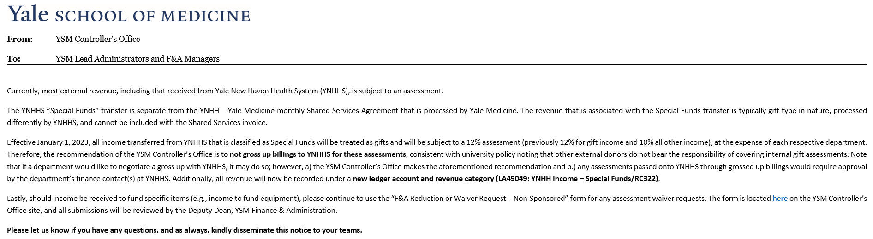

Special Situations & Exceptions
Exceptions to this guideline must be documented using the YSM Policy/ Procedure/ Guideline Exception Request - Form and presented to ysmcontroller@yale.edu.

Roles & Responsibilities
YSM Controller’s Office
- Interpretation and maintenance of guidelines

Contact Information
- YSM Controller’s Office: ysmcontroller@yale.edu

Related Information

References

YSM Non-Sponsored Assessment Reduction or Waiver Request

Version History
- 08/12/2025: Minor grammar edits; also, YSMCO confirmed annual approval for med. staff due fund assessment waiver, as noted in Section 2.8.
- 06/18/2024: New PolicyTech Guideline (was previously developed and communicated in June 2023). Added Scope, Definition, Roles & Responsibilities, Contact Information; modified Current Background; added section 2.8; made grammar and wording nits throughout document

Keywords
YNHH, YNHHS, Special, Funds, YSMCO, Assessment

Responsible Official: Associate Controller, Yale School of Medicine, Deputy Dean Finance & Administration
Document Administrator: Kelsey Schieren
Date of Origin: 06/18/2024
Approval Date: 04/06/2026
The official version of this information will only be maintained in an on-line web format. Any and all printed copies of this material are dated as of the print date. Please make certain to review the material on-line prior to placing reliance on a dated printed version.

