Scope
This document establishes the procedure to be followed by the Yale School of Medicine (YSM) regarding secondary approval of expense reports for Deans, Department Chairs, and Lead Administrators/Senior Directors by the YSM Controller’s office.

Procedure Purpose
Authorization and approval are control activities that mitigate the risk of the occurrence of inappropriate transactions and/or non-compliance with University policies and procedures.

Strong internal controls dictate that there is an approval hierarchy in place to ensure that a subordinate is not the only approver of expense reports for Deans, Department Chairs, and Lead Administrators/Senior Directors, as they have fiduciary responsibility of a department’s funds

Definitions
Deans
The Dean is the administrative officer of Yale School of Medicine and is responsible for the organization.

Deputy Deans report to the Dean and are primarily responsible for assisting the Dean in overseeing activities for the School.

The Dean and Deputy Deans are located here: https://medicine.yale.edu/about/leadership-administration/ysm-dean-deputy-deans/.

Department Chair
A Department Chair is a faculty member in a given academic department who is appointed by the Yale Corporation upon recommendation of the President after nomination by the Dean.

Yale School of Medicine Department Chairs for both clinical and basic science departments are located here: https://medicine.yale.edu/about/leadership-administration/department-chairs/.

Lead Administrator/Senior Director
The Lead Administrator/Senior Director is an individual who is responsible for administrative authority over a department or multiple departments, and they generally report directly to a Department Chair or a Dean. Lead Administrators/Senior Directors can be found here: https://medicine.yale.edu/myysm/people/chair-administrator-assistant/.

Procedure Sections
- Submission/Approval

Submission or approval of an expense incurred by a Dean, Department Chair, or Lead Administrators/Senior Director must submit an approval through Workday.
- Lead Administrator/Senior Director, Department Chair, Deputy Dean, Dean, or their delegate submits expense report in Workday.
- Cost Center P2P 1k Approver reviews expense report.
- If the expense report total is greater than $500, the highest required Cost Center P2P Approver must submit expense report for a secondary approval by using “Add Approver” function in Workday.
  - In situations where the 1k approver also has a 10k approver role and the report is over the 1k limit, the “add approver” can be done at the lower 1k level.
  - Additionally, if a department business office has a practice of adding additional approvers, the 1k role can add the approver, or, they may reach out via email for an email approval. Note: an added approver cannot add additional approvers.
- Under “Add Approver, select “Cost Center YSM Expense Report Approver”.

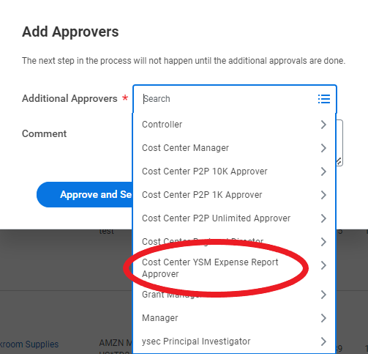

  - Under “Cost Center YSM Expense Report Approver “Associate Controller, Yale School of Medicine.”
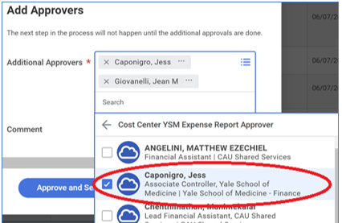

- Associate Controller, Yale School of Medicine performs a secondary review for compliance with University and YSM policies and procedures.
  - Upon review completion, Associate Controller, Yale School of Medicine, approves expense report or sends back for more information within Workday.
- If approved by Associate Controller, Yale School of Medicine, expense report is closed.
- If expense report is sent back, Lead Administrator/Senior Director, Department Chair, Deputy Dean, Dean, or their delegate must resubmit with requested information.

- Monitoring

The YSM Controller’s Office will monitor adherence to this procedure monthly.

- The YSM Controller’s Office will conduct monthly analysis to determine if expense reports are submitted for secondary approval in accordance with Expense Report Secondary Approval: Deans, Chairs, and Lead Administrators/Senior Directors – Policy
- Escalation

The escalation process if failure to comply with the procedure is as follows:

- If a department does not adhere to this procedure on more than three occasions, the matter will be escalated to the Yale School of Medicine’s Deputy Dean of Finance & Administration.

Special Situations & Exceptions
Exceptions to this procedure must be documented using the YSM Policy/ Procedure/ Guideline Exception Request - Form and presented to ysmcontroller@yale.edu.

Roles & Responsibilities

Contact Information

- Clarification of this policy: YSM Controller’s Office ysmcontroller@yale.edu

Related Information
3215 PR.02 Yale Expense Management (PCard and Out-of-Pocket Expenses)
3301 Travel on University Business
3302 Business Meals, Entertainment, and Other Social Events
Expense Report Secondary Approval: Deans, Chairs, and Lead Administrators/Senior Directors – Policy

References

Version History
- 4/6/2026: Removed Coordinator (Jean Giovanelli) and YSM Coordinator from process, the new process will only be additional review by Associate Controller, YSM
- 2/19/2025: Added the process to account for roles where the approver has both 1k and 10k, also added wording if the DBO has a process of adding additional approvers within their department, approvers cannot add approvers.
- 8/1/2023: New Version

Keywords
expense, report, secondar, approval, policy, deans, department, chairs, lead, administrators

Responsible Official: Associate Controller, Yale School of Medicine, Deputy Dean Finance & Administration
Document Administrator: Kelsey Schieren
Date of Origin: 11/11/2008
Approval Date: 05/26/2026
The official version of this information will only be maintained in an on-line web format. Any and all printed copies of this material are dated as of the print date. Please make certain to review the material on-line prior to placing reliance on a dated printed version.

