**Daniel J. Siegwart, Ph.D.**

***Associate Professor***

***Simmons Comprehensive Cancer Center, University of Texas Southwestern Medical Center, Department of Biochemistry, Department of Biomedical Engineering***

**Thursday, December 1, 2022**

**3:00 pm- 4:00 pm**

Trask Conf Rm LMP3108 or Join via Zoom:  
https://yale.zoom.us/j/96084476668

***Hosted by: Dr. Marie Egan***

**“Development of Selective Organ Targeting (SORT) Lipid Nanoparticles (LNPs) for Gene Correction of CFTR Mutations that Cause Cystic Fibrosis”**

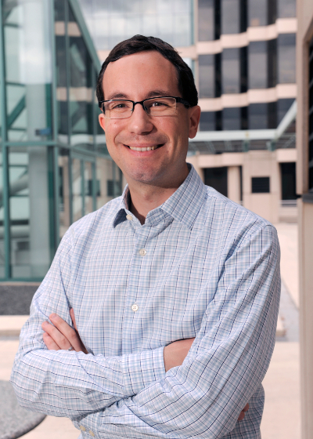

***The Yale CF Research Center***

***Seminar***

***Presented by***

**Pediatric Pulmonology, Allergy, Immunology**

**& Sleep Medicine**