YALE SCHOOL OF MEDICINE
Department of Pathology

2021-22 Research in Progress Series

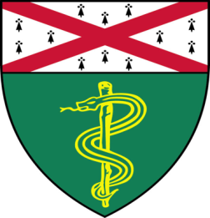

Shruti Desai, (Schalper Lab)
Associate Research Scientist
“Role of DNA Damage Response in Adaptive Immune Responses and Treatment Sensitivity in NSCLC”

And

Sonali Vishal, (Gopal Lab)
Postdoctoral Associate

“Sequence Determinants of TDP-43 Ribonucleoprotein (RNP) Condensate Formation and Axonal Transport in Neurons”

Join TAC Auditorium, N-107, 300 Cedar Street
Coffee & refreshments beforehand- TAC Lobby
or
Join Zoom Meeting
https://zoom.us/j/ 96247765777 Passcode: 889328
Tuesday, May 24th, 9:30-10:30 a.m.

"All the contents are proprietary, unauthorized use of the information is prohibited and unethical".

Questions? Wendy Folsom, Pathology: Wendy.Folsom@yale.edu, LH315, 203-785-3478

