YALE STEM CELL CENTER
& MCDB
Special Joint Seminar

“Artificial spermatid- mediated
genome editing”

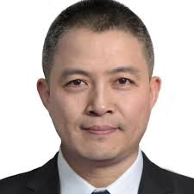
Jinsong Li, Ph.D.
Professor, Director, State Key Laboratory of Cell Biology
CAS Center for Excellence in Molecular Cell Science
Shanghai Institute of Biochemistry and Cell Biology (SIBCB) Chinese Academy of Science

January 28, 2020
Brady Auditorium - 4:00 pm
Host: Haifan Lin, Ph.D.
Host: Weimin Zhong, Ph.D.

Sponsored by the Mrs. Hepsa Ely Silliman Memorial Fund

