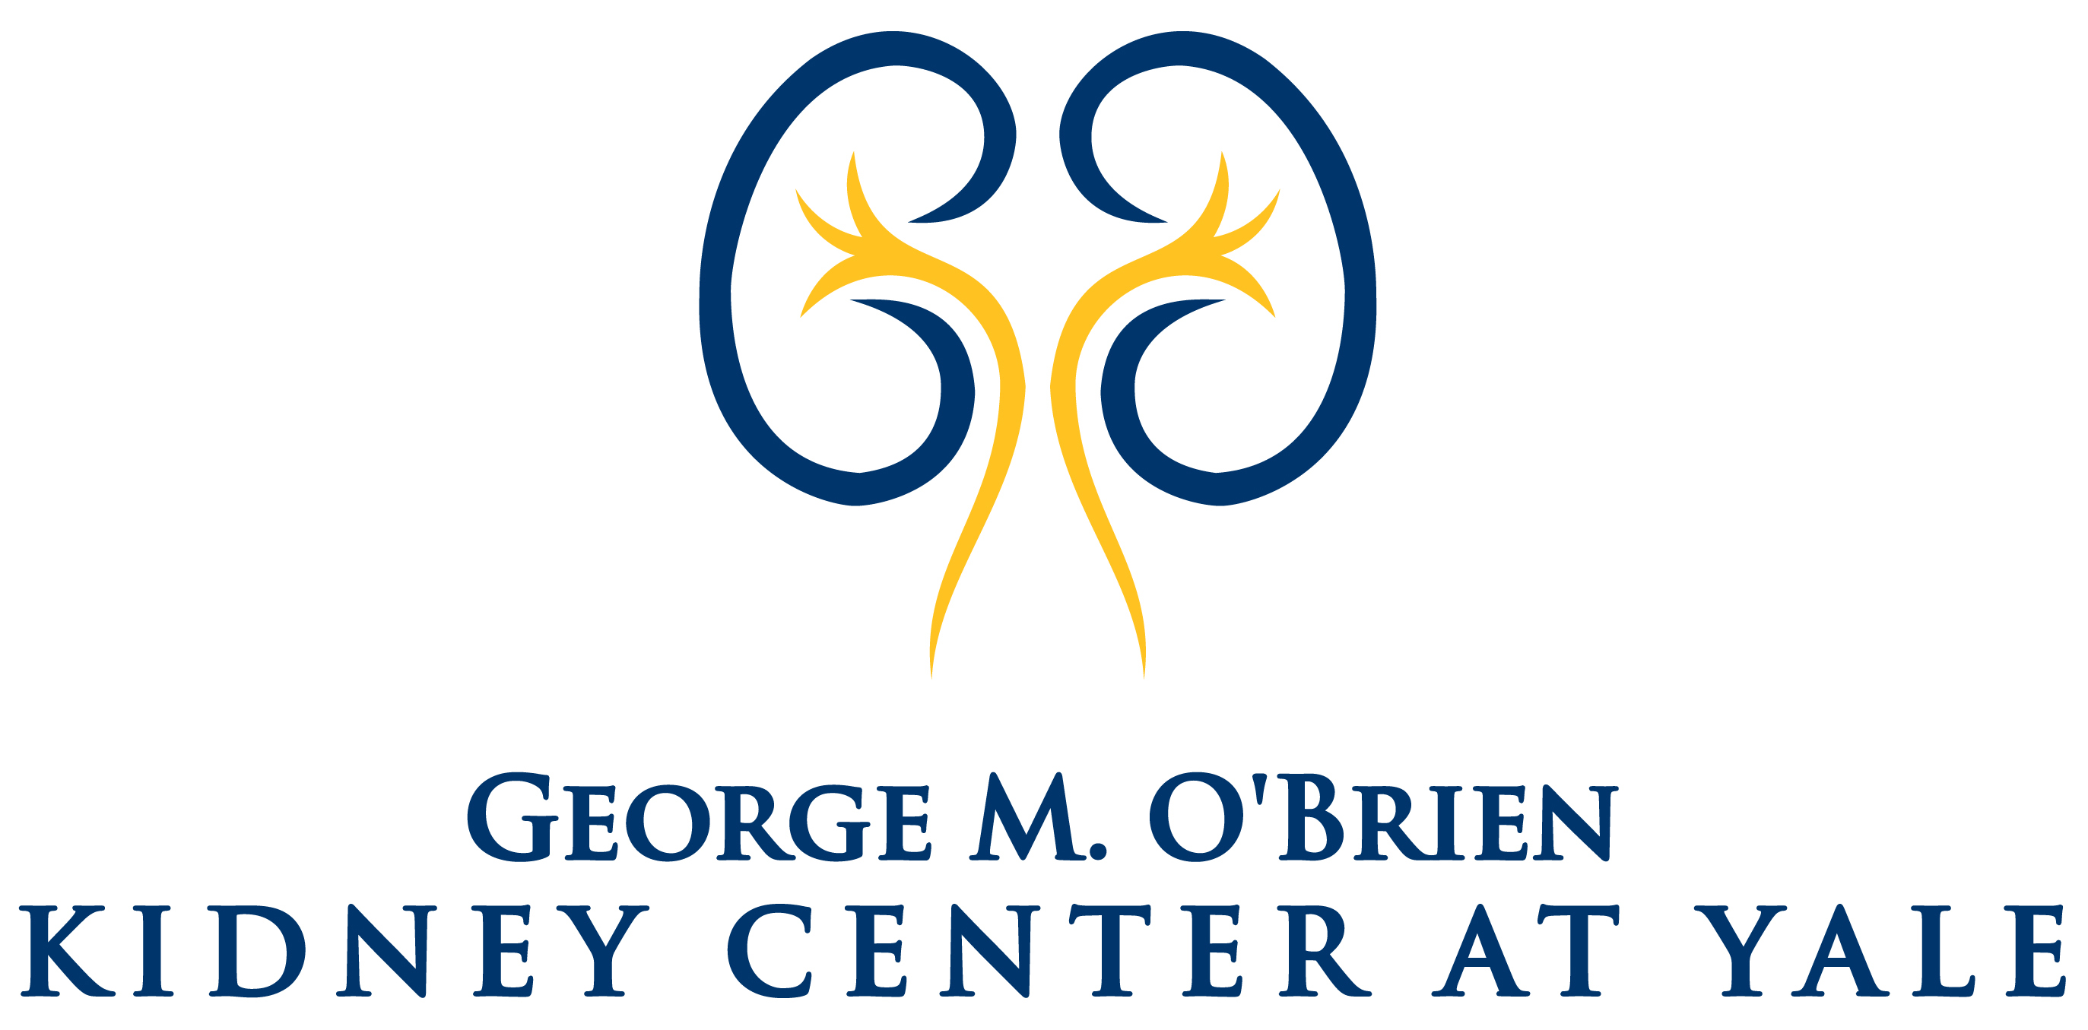

Advances in Kidney Research
George M. O'Brien Kidney Center at Yale

Friday, May 13, 2022

TAC N107 Auditorium

300 Cedar Street, New Haven, CT

8:00 AM Continental Breakfast – TAC Upper Lobby

8:30 AM Introduction and Welcome
Peter S. Aronson, MD
Yale School of Medicine

8:45 AM “Systemic Iron Homeostasis: Translating Molecular Discoveries to
Chronic Kidney Disease (CKD) Patients”
Jodie L. Babitt, MD
Harvard Medical School

9:30 AM “Genetic Complexity in ADPKD”
Peter C. Harris, PhD
Mayo Clinic

10:15 AM Break

10:30 AM “Old is New in Diabetic Nephropathy”
Sylvia E. Rosas, MD, MSCE
Harvard Medical School

11:15 AM “Epidemiology of Kidney Stone Disease: From Origins to Complications”
Michelle R. Denburg, MD, MSCE
The Children's Hospital of Philadelphia

12:00 PM Luncheon Break

1:00 PM “Translational Insights from Patients’ Stem Cell-Derived Model of APOL1 Nephropathy”
Opeyemi A. Olabisi, MD, PhD
Duke University Medical Center

1:45 PM Concluding Remarks
Peter S. Aronson, MD
Yale School of Medicine

Symposium will be “live” in TAC N107 and available via Zoom

Zoom instructions will be sent prior to the event

For additional information, please contact anne.prodoti@yale.edu

