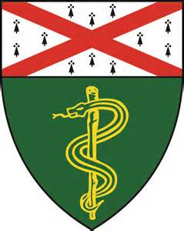
Palliative Care Conference
Tuesday, October 22nd @ 4pm
Fitkin (FMP) 6th Floor, Conference Rm 618
(see bottom of flyer for directions)
4-6:00pm

Journal Club Presentation

Presenter: Dmitry Kozhevnikov, DO
Director, Outpatient Palliative Care; Smilow Care Centers
Title: “Patient Patterns and Perspectives on Using Opioid Regimens for Chronic Cancer Pain”

Palliative Case Conference

Presenter: Melissa Weimer, MD
Medical Director of the Addiction Medicine Consult Service, Program in Addiction Medicine, Yale Internal Medcine
Title: “Addressing Addiction at the End of Life”

Directions to Fitkin (FMP) Room F-618 Conference Room
Take elevator to 6th floor. Exit elevator and take u-turn to the right. You will see a closed glass door with “Psychological Medicine Service and Interpreter Services” sign. The glass door is unlocked – enter and look for F-618 down hall on the left.

Please contact Lisa.Arnel@yale.edu for additional information

