YALE SCHOOL OF MEDICINE
Department of Pathology

2019-20 Research in Progress Series

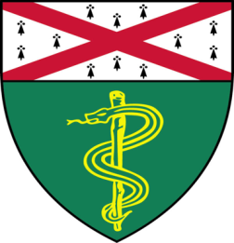

Muhammad Riaz, (Qyang Lab)
Associate Research Scientist

“Learning Heart Mechanobiology From a Hypertrophic Cardiomyopathy Family”

Tuesday, February 4th, 2020
9:30 to 10:30 a.m.
TAC Auditorium, N-107, 300 Cedar Street

Coffee & refreshments beforehand- TAC Lobby

Questions? Wendy Folsom, Pathology: Wendy.Folsom@yale.edu, LH315, 785-3478

