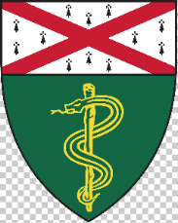
PET Talks
Seminars By and For PET Users


Longitudinal PET Studies of Synaptic Density in Neurodegenerative Disorders
Koen Van Laere, MD, PhD
Professor, Faculty of Medicine
Head, Nuclear Medicine and Molecular Imaging
KU Leuven
Monday, September 19, 2022
9:00 AM (Please arrive early for breakfast)
Brady B131 Auditorium, 310 Cedar St.
Zoom: https://yale.zoom.us/j/94713276586?pwd=ZmhlMWxxb1JlblpSSjFmSFE0U25FQT09 Password 152941
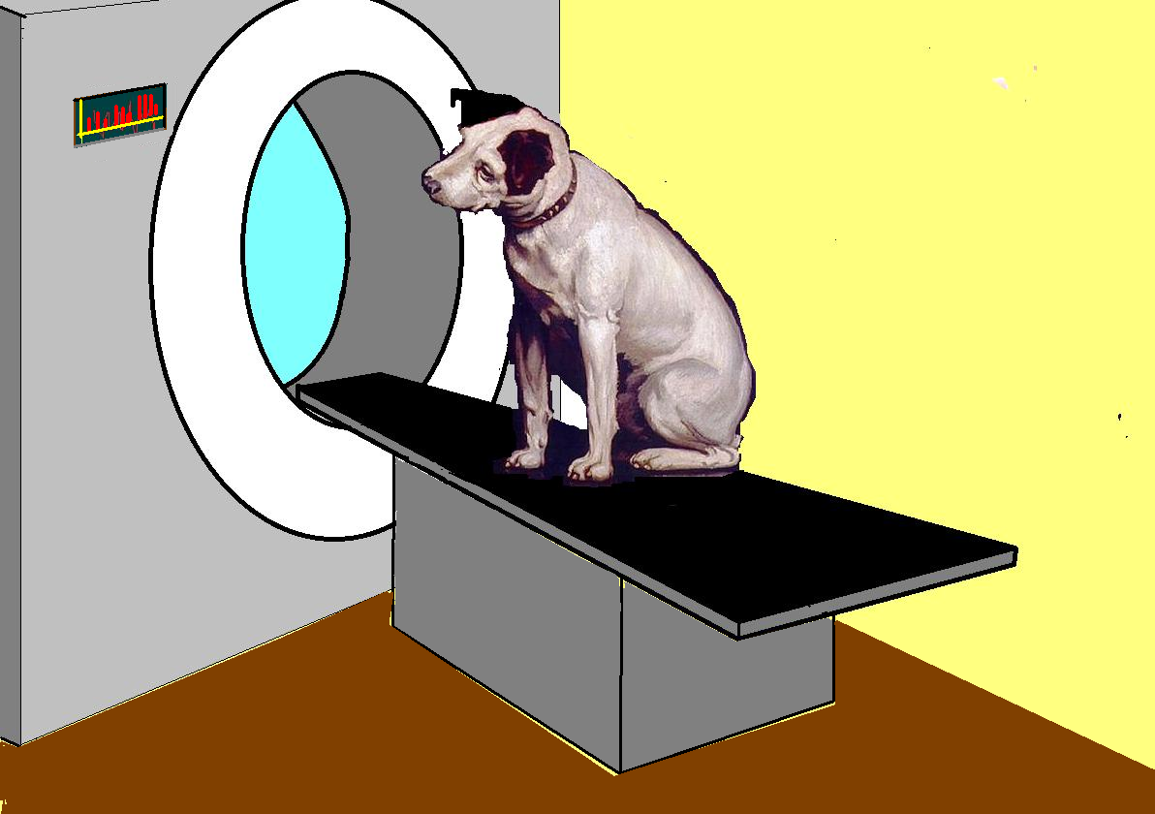

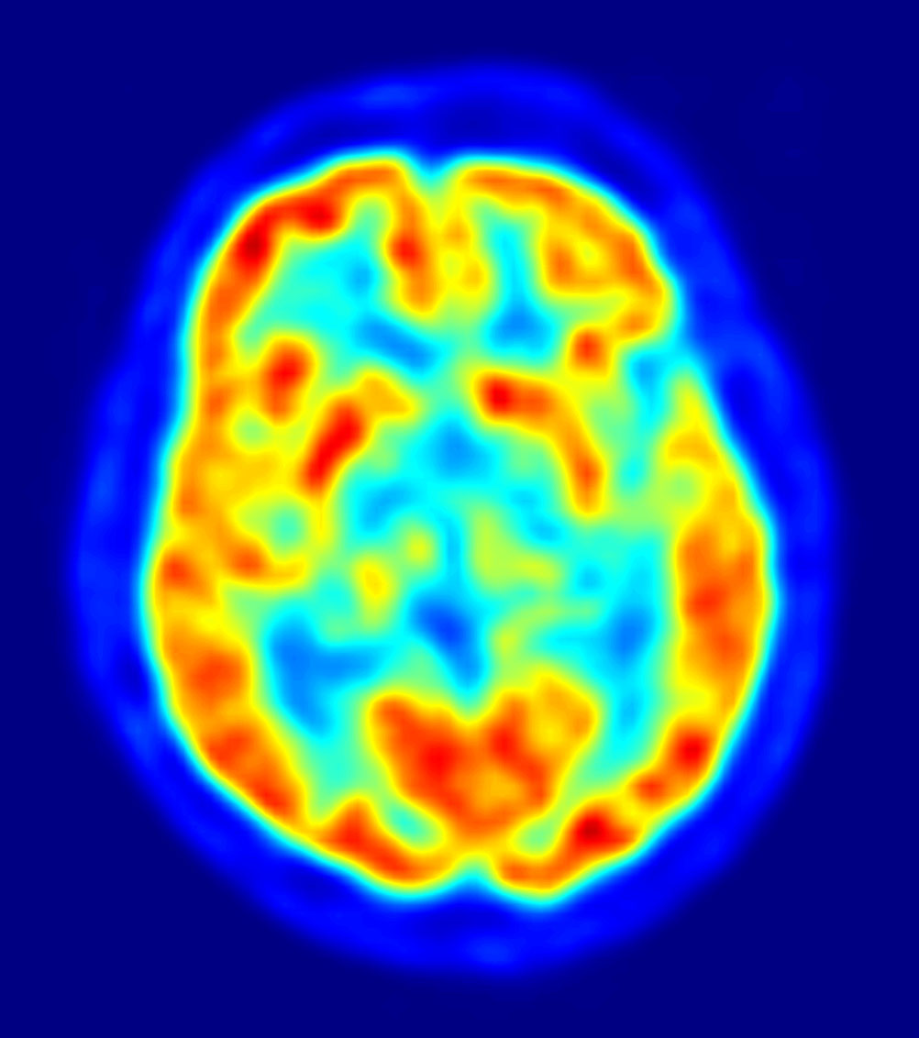
Abstract: Positron Emission Tomography of synaptic density provides a new view to understand and monitor synaptic damage as one of the core features common to many neurodegenerative disorders. This talk will discuss longitudinal in vivo changes of synaptic density in patients with amnestic mild cognitive impairment, Parkinson’s and Huntington’s disease, and how this relates to (changes in) currently used imaging markers (e.g. ¹⁸F-FDG, ¹⁸F-PE2I dopamine transporter PET) or recently developed markers for underlying proteinopathy (such as ¹⁸F-MK6240 for tau and ¹¹C-CHDI-180R for mutant huntingtin).
PET Talks

