YALE SCHOOL OF MEDICINE
Department of Pathology

2020-21 Research in Progress Series

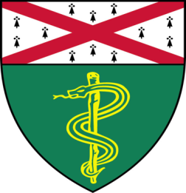

Xiuqi (Jade) Li, (Finberg Lab)
Ph.D. Candidate

“Dissecting the Regulation of
FGF23 by Iron”

And

John Gonzalez, (M. Levine Lab)
Ph.D. Candidate

“Lipid Nanoparticles to Deliver Partial Reprogramming Agents”

Join Zoom Meeting
https://zoom.us/j/95032258483
Passcode: 889918

Tuesday, February 23rd, 9:30-10:30 a.m.

"All the contents are proprietary, unauthorized use of the information is prohibited and unethical".

Questions? Wendy Folsom, Pathology: Wendy.Folsom@yale.edu, LH315, 203-785-3478

