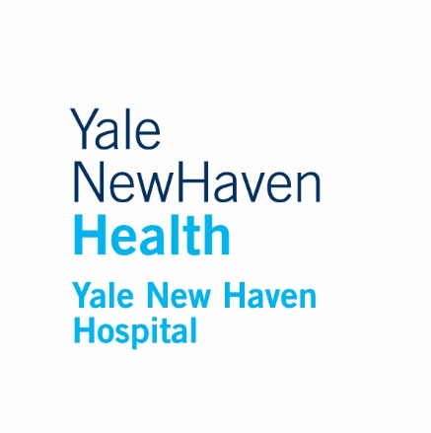

2022 Yale Health System APP Week Recognition Awards
Nomination Form

Eligible nominees must be credentialed with Yale Health System as a certified nurse midwife (CNM), certified registered nurse anesthetist (CRNA), nurse practitioner (APRN), or physician assistant (PA) and also must have a typed, completed application in its entirety submitted by:
DEADLINE DATE: OCTOBER 21st @ 5PM
Award categories include Clinical Leader, Distinguished APP Leader, Clinical Excellence, Education, Humanitarian, Mentorship, Publishing, Outstanding Newcomer, and APP of the Year. Each APP Nominator may only nominate one APP for each category. Please be sure to select only one category per nomination.
*Prior award recipients are not be eligible to receive the same consecutive award as the preceding year, however may still be nominated for awards in alternative categories.

APP Name: ____________________________________
Award Category: (may only list one) ____________________

Department: __________________________________
Specialty/Service Line: __________________________

APP Nominator: ________________________________
Nomination Supported/Endorsed by: Manager: __________________________________________________________
Supervising/Collaborating Physician: ____________________________________
Please include a well articulated, meaningful, detailed narrative with a focus on both reason and impact of how the award nominee embodies the entirety of the 2022 YHS APP Week Award listed above: (Please include typed attachment)

Please return completed typed nomination form to Theresa.cohen@ynhh.org
If this application is not completed in its entirety at time of initial submission it will not be advanced for review.
DEADLINE DATE: OCTOBER 21st @ 5PM
The YNHH APP Week Planning Committee graciously thanks the YNHH Medical Staff Engagement Committee, the Office of the Chief Medical Officer, the Office of the Chief Nursing Officer and the Center for Advanced Practice for their supportive efforts.

