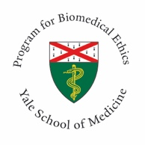
Presented by: Medical Education - Yale Program for Biomedical Ethics and Yale New Haven Health System Center for Clinical Ethics

Inaugural Ernest Moritz Lecture in Ethics and Palliative Care
COVID, Community, & Dying Alone
4/13/2022 5:00 PM − 6:30 PM Online via Zoom
The Program for Biomedical Ethics at Yale School of Medicine provides multidisciplinary leadership regarding the ethical and social aspects of health care and medical research. Our interdisciplinary team draws upon philosophy, law and social and behavioral sciences to provide expert biomedical ethics consultations for families, researchers, physicians and other health care providers. The Program for Biomedical Ethics develops and presents various ethics-related educational programs throughout the academic year for medical, nursing and physician assistant students, the community, Yale faculty and local, regional and national health care professionals. Mark Mercurio, MD, MA, is the Director of the Program for Biomedical Ethics. The Associate Directors of the Program for Biomedical Ethics are John S. Hughes, MD and Sarah Hull, MD.
Texting code for today’s session: 30647
Zoom registration: https://zoom.us/webinar/register/WN_zoP_T4r8TLieiEQ80Znf0w
Faculty:
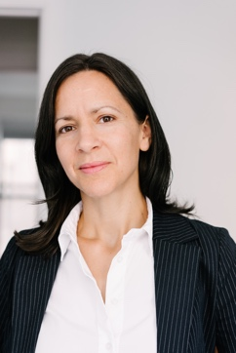
Lydia Dugdale, MD, MAR
Dorothy L. and Daniel H. Silberberg Associate Professor of Medicine
Director, Columbia Center for Clinical Medical Ethics
Associate Director of Clinical Ethics, NYP
Associate Professor of Medicine, Columbia University Vagelos College of Physicians and Surgeons
Mark Mercurio, MD, MA
Professor of Pediatrics, Yale School of Medicine
Chief, Division of Neonatal-Perinatal Medicine
Director, Program for Biomedical Ethics

Program Goals:
1 1. Describe COVID-era visitor restrictions
2 2. Articulate the harms of loneliness
3 3. Recount lessons from the Bubonic Plague
Target Audience: Critical Care Medicine, Emergency Medicine, Family Practice, General Practice,
Internal Medicine, Psychiatry, Geriatric Medicine, Multiple Specialties, Nurse Practitioner, Physician Assistant,
Psychology, Public Health, Social Work, Infectious Diseases, Pulmonology, Primary Care, Physical Medicine &
Rehabilitation

Financial Disclosure Information:
Dr. Lydia Dugdale and Dr. Mark Mercurio have nothing to disclose.
Accreditation Statement: Yale School of Medicine is accredited by the Accreditation Council for Continuing Medical Education (ACCME) to provide continuing medical education for physicians.
Designation Statement: Yale School of Medicine designates this Live Activity for a maximum of 1.50 AMA PRA Category 1 Credit(s)™. Physicians should only claim credit commensurate with the extent of their participation in the activity.
For questions, email karen.kolb@yale.edu.

