Presented by: The Department of Pediatrics
Paul S. Goldstein, MD Lectureship

Hypothalamic-Pituitary Dysfunction after Childhood Cancer Treatment: Clinical Pearls for the Endocrinologist and Pediatrician
5/18/2022 12:00:00 PM−5/18/2022 1:00:00 PM | Medical Campus
The Pediatric Subspecialty Lecture series is a multidisciplinary series. The series includes one hour lectures and case presentations that update our pediatric subspecialist physicians, learners and other healthcare professionals on cutting edge biomedical sciences, clinical and educational practices, presenting this information in an understandable and clinically useful format, that informs the health care delivery and improves outcomes of children and adolescents. Pediatric Subspecialty lecture topics are varied.
Texting code for today’s session: 29726

Faculty:
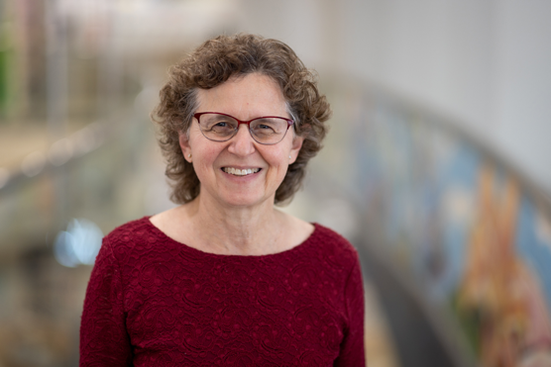
Laurie E Cohen, MD
Chief, Division of Pediatric Endocrinology & Diabetes
The Children's Hospital at Montefiore

Program Goal:
1 Recognize that endocrine complications are common in childhood cancer survivors (CCS)
2 Recognize the risks of growth hormone deficiency and and other factors that impair growth in CSS
3 Recognize the risks of other anterior pituitary hormone deficiencies (APHD) in CCS
4 Understand the limitations in testing for APHD
Target Audience: Pediatrics
Financial Disclosure Information:
Laurie E. Cohen, MD: Honoraria-Novo Nordisk (Relationship has ended)|Grant or research support-Pfizer|Honoraria-The Children's Hospital at Montefiore (Relationship has ended) - 05/02/2022

Accreditation Statement: Yale School of Medicine is accredited by the Accreditation Council for Continuing Medical Education (ACCME) to provide continuing medical education for physicians.
Designation Statement: Yale School of Medicine designates this Live Activity for a maximum of 1.00 AMA PRA Category 1 Credit(s)™. Physicians should only claim credit commensurate with the extent of their participation in the activity.
For questions, email andrew.taylor@yale.edu.

