ANNUAL FALL SYMPOSIUM

GLOBAL HEALTH EXPERIENCES THROUGH THE
DOWNS FELLOWSHIP

October 30th, 2019 3-5pm
Donald J. Cohen Auditorium NIHB E Floor
230 South Frontage Road

3:00-3:30pm Food and Poster Presentations
3:45-4:00pm Opening Remarks and Welcome Address
4:00-4:30pm Oral Presentations

Nkandu Yumbe, Yale School of Public Health
An Investigation on Intimate Partner Violence (IPV), Colorism and Stress
Coping Behaviours in Black Bajan Women
Faculty Advisor: Saria Hassan, MD

Sakura Oyama, Yale School of Medicine
Relationship Between CREBRF Genotype, Adiposity and Resting Metabolic
Rate in Samoan Infants
Faculty Advisor: Nicola Hawley, PhD

Harry Hyunteh Kim, Yale School of Public Health
Investigating the Community-Level Variation of Soil-Transmitted Helminth
Prevalence in Kpandai District, Ghana: A Qualitative Study
Faculty Advisor: Debbie Humphries, PhD, MPH

Carlye Chaney, Graduate School of Arts and Sciences, Anthropology
Investigating Endocrine Disrupting Chemicals in Two Argentine Indigenous Populations
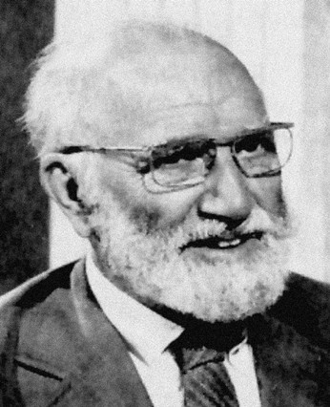
Faculty Advisor: Claudia Valeggia, PhD

4:30-5:00 Poster Presentations

The Wilbur Downs Fellowship Program is supported by an endowment in honor of Wilbur G. Downs, MD, MPH.
The Fellowship is carried out under the auspices of the Wilbur Downs Fellowship Committee
and Yale School of Public Health. CONTACT: ANJULI.BODYK@YALE.EDU

