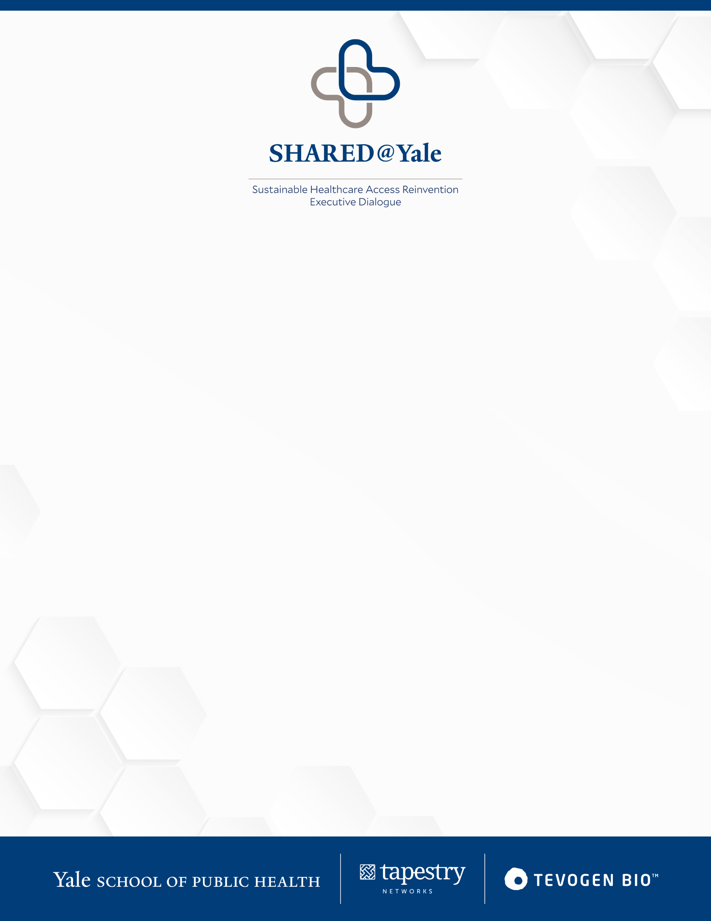
Inaugural Roundtable on Post-COVID Health Care
To address new business models for health care in the post-COVID world, the Yale School of Public Health will be hosting the inaugural Sustainable Healthcare Access Reinvention – Executive Dialogue (SHARED@Yale), an online roundtable bringing together leaders in business, medical innovation and public health. The 90-minute panel discussion, sponsored by Tevogen Bio, will be live streamed for worldwide viewing on November 30 at 11:30 a.m. EST. The event is open to everyone.
Registration link: https://yale.zoom.us/webinar/register/WN_bjggO08kRqO1u6sXgiOhng
The roundtable will be chaired by Sten Vermund, dean of the Yale School of Public Health, and co-facilitated by Lindee Goh, Tapestry Networks. The panelists will explore the pandemic’s influence on the American health care system and identify opportunities to rethink its major elements for a more equitable future. Panelists include:
- Bob Galvin: Chief medical officer and senior partner, Blackstone investment firm
- Bill Novelli: Founder, Georgetown Business for Impact
- Marcella Nunez-Smith: Chair, Presidential COVID-19 Health Equity Task Force; Senior Advisor, White House COVID-19 Response Team; Associate Dean, Health Equity Research, Yale School of Medicine
- Joshua Steiner: Chairman of Castleton Commodities and Senior Advisor at Bloomberg L.P.Major
- Major General Irene Trowell-Harris: Former director of the Department of Veterans Affairs Center for Women Veterans
“We wish to learn from recent successes and address chronic challenges of health access, including inequities, inefficiencies, and suboptimal outcomes in care. We will also reimagine the biopharma business model towards provision of low-cost advanced therapeutics for all.”
- Sten Vermund, dean of the Yale School of Public Health

