Yale GIM's Inaugural Inginia Genao Lecture in Diversity, Equity, and Inclusion
Presented by
Yale School of Medicine’s Department of Internal Medicine
Section of General Internal Medicine

"Grounded in History & Place:
Critical Science for Health Justice & The People’s Health"

Nancy Krieger, PhD

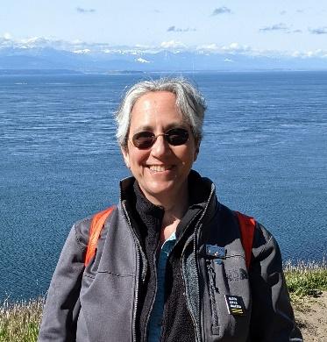

Professor of Social Epidemiology
Department of Social and Behavioral Sciences

Harvard T.H. Chan School of Public Health, Boston, MA

Date: September 22, 2022 12:00pm – 1:00pm

Location: Donald J. Cohen Auditorium*, NIHB E 02 - 230 South Frontage Rd.
*If attending in person, please RSVP to Michele.Manganello@Yale.edu

Zoom: https://yale.zoom.us/j/95746029979

Texting code for today’s session: TBA

Course Director/Host: Patrick G. O’Connor, MD, MPH, 203-688-6532
There is no corporate or commercial support for this activity
Program Goal:
1. Learn critical concepts relevant to analyzing and intervening on health inequities
2. Learn about the impacts of spatial social polarization, Jim Crow, and historical redlining in shaping contemporary health inequities
3. Learn about core features of the ecosocial theory of disease distribution
Target Audience: Medical Professionals (change as needed)
Financial Disclosure Information: Nancy Krieger has no relevant financial relationship(s) with ineligible companies to disclose.

Dr. O’Connor, course director and faculty member for the Yale General Internal Medicine Faculty Meetings, has no relevant financial relationship(s) with ineligible companies to disclose.

Patti Cavaliere, Vivian DuBrava, Michele Manganello, and Toni Boulay, coordinators/planners for the Yale General Internal Medicine Faculty Meetings, have no relevant financial relationship(s) with ineligible companies to disclose

Accreditation Statement: Yale School of Medicine is accredited by the Accreditation Council for Continuing Medical Education (ACCME) to provide continuing medical education for physicians.

Designation Statement: Yale School of Medicine designates this Live Activity for a maximum of 1.00 AMA PRA Category 1 Credit(s)™. Physicians should only claim credit commensurate with the extent of their participation in the activity.

