YALE SCHOOL OF MEDICINE
Department of Pathology

2019-20 Research in Progress Series

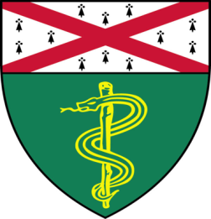

Viswanathan Muthusamy
Research Scientist

“Preclinical Investigation of Anti-Cancer Therapeutics at the Yale Center for Precision Cancer Modeling”

And

Taylor Takasugi, (Chang Lab)
Ph.D. Student
“Pot1b Regulation of Telomere
Length Maintenance”

Tuesday, October 22nd, 2019
9:30 to 10:30 a.m.
TAC Auditorium, N-107, 300 Cedar Street

Coffee & refreshments beforehand- TAC Lobby

Questions? Wendy Folsom, Pathology: Wendy.Folsom@yale.edu, LH315, 785-3478

