YALE SCHOOL OF MEDICINE
Department of Pathology

2020-21 Research in Progress Series

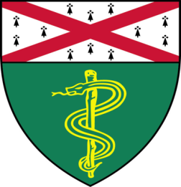

Myrto Moutafi, M.D., MSc, (Rimm Lab)
Postdoctoral Associate

“Discovery of Biomarkers of Response or Resistance
to Immune Checkpoint Blockade in
Non-Small-Cell Lung Cancer (NSCLC) using
High-Plex Digital Spatial Profiling”

And

Luke Batty, BS, MS, (Qyang Lab)
Ph.D. Candidate

“Vascular Smooth Muscle Cells Derived
From Pig Induced Pluripotent Stem Cells for
Vascular Tissue Engineering”

Join Zoom Meeting
https://zoom.us/j/95032258483
Passcode: 889918

Tuesday, May 11th, 9:30-10:30 a.m.
"All the contents are proprietary, unauthorized use of the information is prohibited and unethical".

Questions? Wendy Folsom, Pathology: Wendy.Folsom@yale.edu, LH315, 203-785-3478

