Yale Rheumatology Grand Rounds
Presented by
Yale School of Medicine’s Department of Internal Medicine
Section of Rheumatology, Allergy & Immunology

Global Rheumatology Research: Frontiers, Challenges and Opportunities
Date: Wednesday, September 29, 2021 from 9/29/2021 8:00 AM−9:00 AM | Online
Texting code for today’s session: 29470
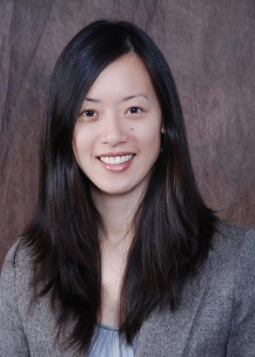
Evelyn Hsieh, MD, PhD
Assistant Professor of Medicine; Chief of Rheumatology, VA Connecticut Healthcare System; Assistant Professor of Epidemiology (Chronic Diseases)

Course Director: Fotios Koumpouras, MD
Program Goal:
1 To discuss the global burden of musculoskeletal and rheumatic diseases.
2 To describe the challenges and rewards faced by rheumatology researchers from low-resource settings, and some of the strategies that groups from different regions have used to address these barriers.
3 To understand the vicious cycle of the global rheumatology research gap, the importance role of different stakeholders in bridging these gaps.
Target Audience: Rheumatology
Financial Disclosure Information:
Accreditation Statement: Yale School of Medicine is accredited by the Accreditation Council for Continuing Medical Education (ACCME) to provide continuing medical education for physicians.
Designation Statement: Yale School of Medicine designates this Live Activity for a maximum of 1.00 AMA PRA Category 1 Credit(s)™. Physicians should only claim credit commensurate with the extent of their participation in the activity.
There is no corporate or commercial support for this activity.

