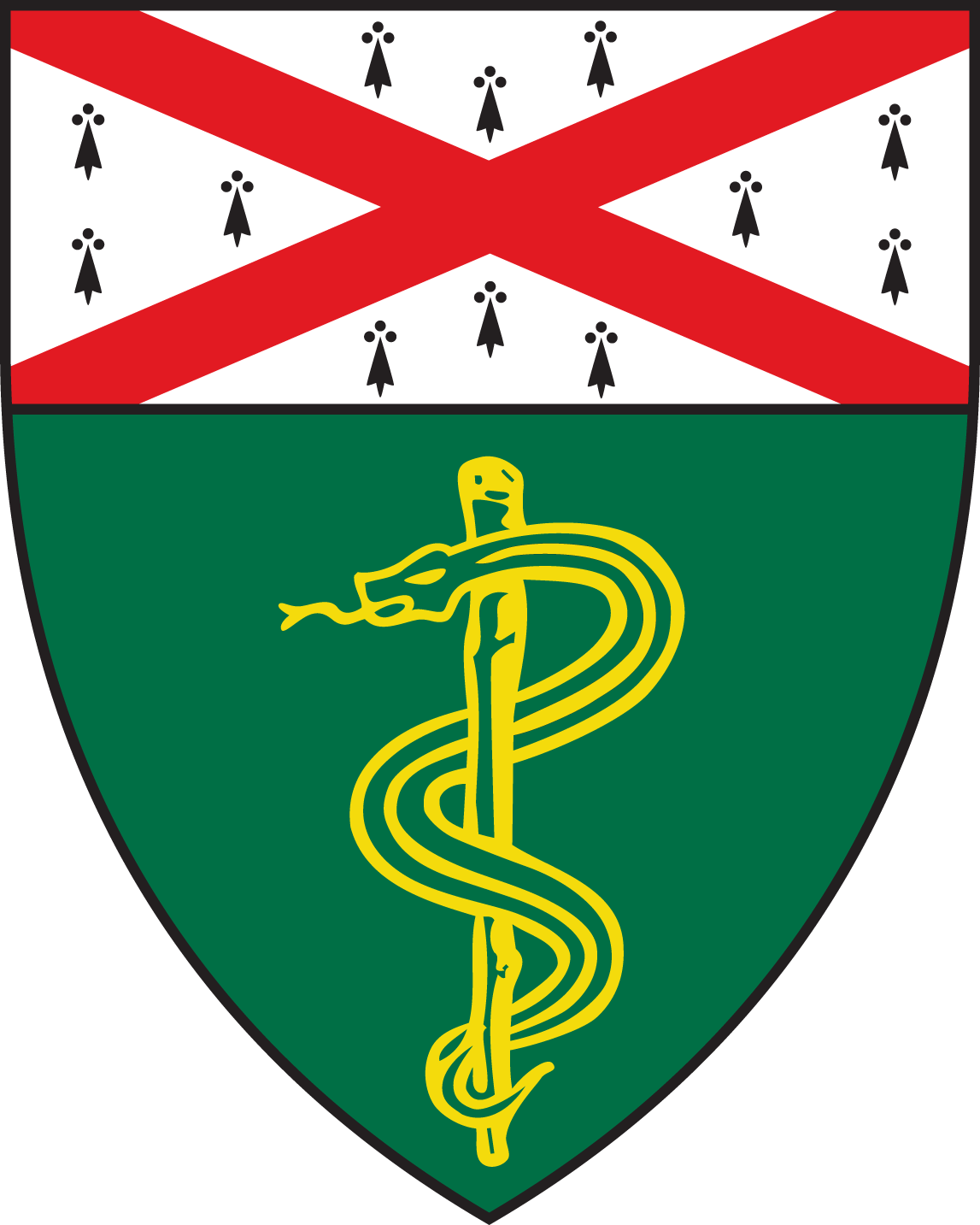
Pulmonary Research Conference

Matt Altman, MD, MA
Assistant Professor Allergy, Asthma and Immunology Clinic, and Allergy & Infectious Disease and Medicine
University of Washington Medical Center

Pediatric Asthma Pathogenesis; insights through Translational Multiomics

Thursday, October 10, 2019
12:00 – 1:00PM
TAC S447

