VIRTUAL SEMINAR
Recent Innovations in Air Pollution Exposure Science: Particle Oxidative Potential and Deep Learning for Exposure Prediction
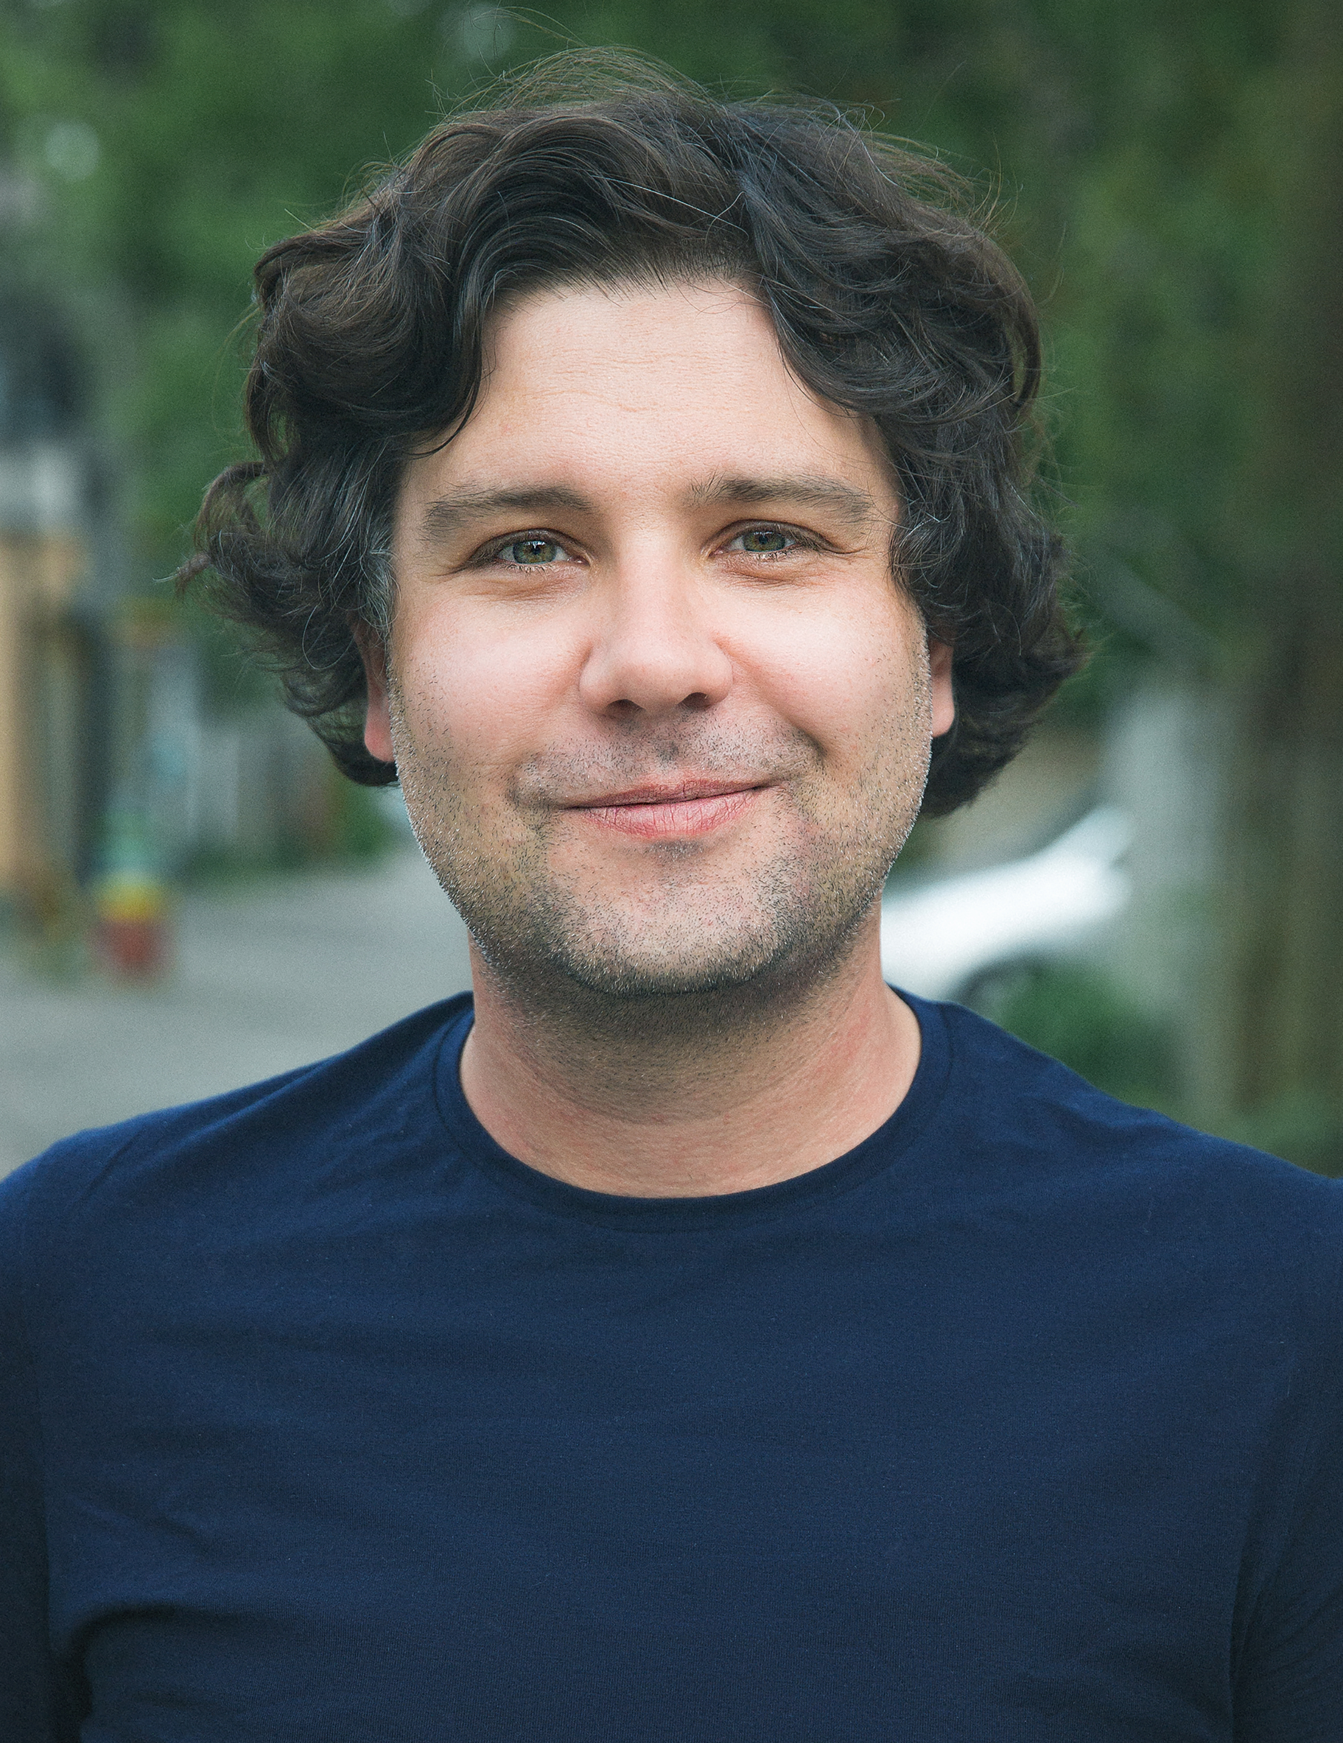
Scott Weichenthal, PhD
Associate Professor
Department of Epidemiology and Biostatistics
McGill University
Dr. Weichenthal received his Master of Science in Occupational Health in 2005 and his PhD in Environmental Epidemiology & Exposure Science in 2008 from the McGill University in Montreal, Canada. His research program is dedicated to identifying and evaluating environmental risk factors for chronic illnesses such as cancer and cardiovascular disease. To support this objective, Dr. Weichenthal develops new approaches to population-based exposure assessment and examines how the urban built environment influences environmental exposures at both the individual and population-level. His past studies have examined the health effects of air pollution from biomass burning, traffic (e.g., ultrafine particles), as well as the oxidative potential of fine particulate air pollution (PM2.5). His current research is examining the use of deep learning models in estimating environmental exposures on both a local and global scale.

12-1 p.m. EST. Wednesday, November 3, 2021
LEPH 101, 60 College Street
Zoom link: https://yale.zoom.us/j/94199922029

