YALE SCHOOL OF MEDICINE
Department of Pathology

2021-22 Research in Progress Series

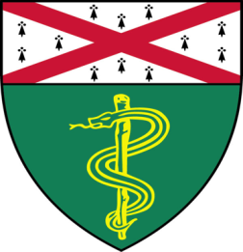

Kishu Ranjan, PhD (Schalper Lab)
Postdoctoral Associate

“Defective HLA Class-1 Antigen Presentation
as Dominant Immune Evasion Mechanism
in Human Lung Cancer”

And

Pablo Fernandez Tussy, (Fernandez-Hernando Lab)
Postdoctoral Fellow

“Dissection of Liver Specific miR-33
Role in NAFLD Progression”

Join Zoom Meeting

https://zoom.us/j/96247765777
Passcode: 889328
Tuesday, February 1st, 9:30-10:30 a.m.
"All the contents are proprietary, unauthorized use of the information is prohibited and unethical".

Questions? Wendy Folsom, Pathology: Wendy.Folsom@yale.edu, LH315, 203-785-3478

