Observed University, State, and Federal Holidays Academic Year July 2025 through June 2026

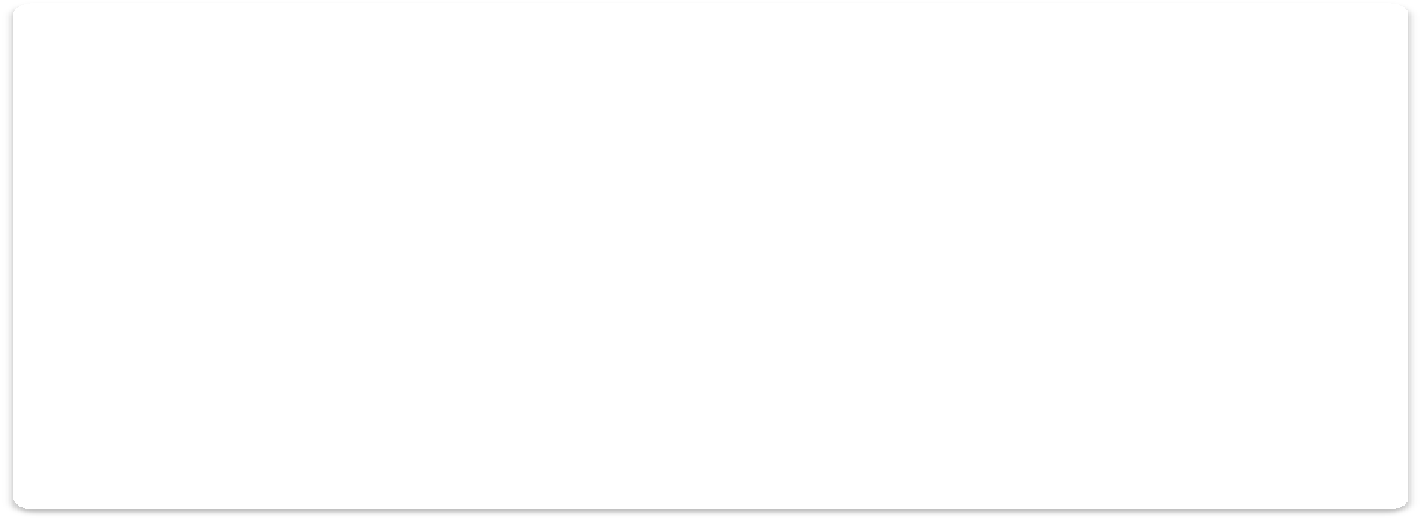

**Rev. 2/12/25 (FA)**

|  |  |  |  |  |
| --- | --- | --- | --- | --- |
| **HOLIDAY** | **YALE UNIV** | **CMHC** | **VACHS** | **YNHH/YPH** |
| ***Independence Day*** | **July 4th** | **July 4th** | **July 4th** | **July 4th** |
| ***Labor Day*** | **September 1st** | **September 2nd** | **September 2nd** | **September 2nd** |
| ***Columbus Day*** | **-----** | **October 13th** | **October 13th** | **-----** |
| ***Veterans Day*** | **-----** | **November 11th** | **November 11th** | **-----** |
| ***Thanksgiving*** | **November 27th – 28th** | **November 28th** | **November 28th** | **November 28th** |
| ***Christmas & Recess*** | **December 24th – 31st** | **December 25th** | **December 25th** | **December 25th** |
| ***New Year’s Day*** | **January 1st** | **January 1st** | **January 1st** | **January 1st** |
| ***Martin Luther King, Jr. Day*** | **January 19th** | **January 19th** | **January 19th** | **January 19th** |
| ***Lincoln’s Birthday*** | **-----** | **February 12th** | **-----** | **-----** |
| ***Washington’s Birthday***  ***(Presidents’ Day)*** | **-----** | **February 16th** | **February 16th** | **-----** |
| ***Good Friday*** | **April 3rd** | **April 3rd** | **-----** | **-----** |
| ***Memorial Day*** | **May 25th** | **May 25th** | **May 25th** | **May 25th** |
| ***Juneteenth National***  ***Independence Day*** | **June 19th** | **June 19th** | **June 19th** | **-----** |