Yale General Internal Medicine
GIM Clinical Conference Series

“Screening for Prostate Cancer: Progress and Promise”

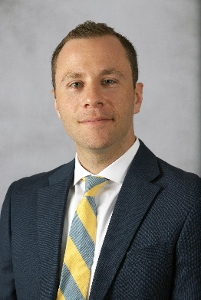
Micheal Leapman, MD
Assistant Professor of Urology
Yale School of Medicine

Date: Thursday, September 12, 2019
7:30am – 8:30am
Location: The Anlyan Center 2nd Floor
TAC Rm, N203 (300 Cedar Street)

Yale General Internal Medicine Faculty Meetings
Course Director/Host: Lisa Puglisi, MD 203-785-7411
There is no corporate or commercial support for this activity
This course will fulfill the licensure requirement set forth by the State of Connecticut

ACCREDITATION
The Yale School of Medicine is accredited by the Accreditation Council for Continuing Medical Education to provide continuing medical education for physicians.

TARGET AUDIENCE
Faculty, residents, students and staff involved in education of health care professional trainees.

NEEDS ASSESSMENT
There is an important need for general internists to understand the value of community level primary care assessment for policy and health planning, and the advantages of community-based participatory research methods for studying health systems.

LEARNING OBJECTIVES
At the conclusion of this activity, participants will be able to:

1. Understand the current state of evidence regarding early detection practices for prostate cancer.
2. Understand challenges, risks and benefits associated with prostate cancer early detection.
3. Understand current efforts underway in the health system to improve stewardship of prostate cancer screening when it occurs.
DESIGNATION STATEMENT
The Yale School of Medicine designates this live activity for 1 AMA PRA Category 1 Credit(s)™. Physicians should only claim the credit commensurate with the extent of their participation in the activity.

FACULTY DISCLOSURES
Dr. Leapman has no conflicts of interest to disclose. Dr. Lisa Puglisi, Course Director, has no conflicts of interest to disclose.

It is the policy of Yale School of Medicine, Continuing Medical Education, to ensure balance, independence, objectivity and scientific rigor in all its educational programs. All faculty participating as speakers in these programs are required to disclose any relevant financial relationship(s) they (or spouse or partner) have with a commercial interest that benefits the individual in any financial amount that has occurred within the past 12 months; and the opportunity to affect the content of CME about the products or services of the commercial interests. The Center for Continuing Medical Education will ensure that any conflicts of interest are resolved before the educational activity occurs.

