YALE SCHOOL OF MEDICINE
Department of Pathology

2019-20 Research in Progress Series

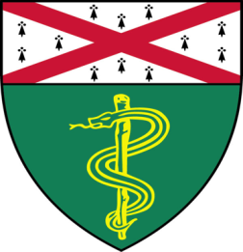

Irina Krykbaeva, (Bosenberg Lab)
Ph.D. Candidate

“Myeloid Targeting in Combination with
PD1 Inhibition Boosts Anti Tumor
Immunity to Melanoma”

And

Keisuke Aoshima, DVM, PhD, (Yan Lab)
Visiting Research Scientist
“The Roles of KDM5A and KDM5B in Triple Negative Breast Cancer”

Tuesday, December 3rd, 2019
9:30 to 10:30 a.m.
TAC Auditorium, N-107, 300 Cedar Street

Coffee & refreshments beforehand- TAC Lobby

Questions? Wendy Folsom, Pathology: Wendy.Folsom@yale.edu, LH315, 785-3478

