YALE SCHOOL OF MEDICINE
Department of Pathology

2021-22 Research in Progress Series

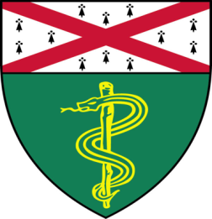

Jinkyu Park (Qyang Lab)
Associate Research Scientist

“Endothelial Regeneration For Single Ventricle Repair Using Induced Pluripotent Stem Cells”

And
Judit Jimenez Sainz, PhD (Jensen Lab)
Associate Research Scientist

“Molecular Mechanisms of BRCA2
Cancer-Associated Missense Mutations”

Join Zoom Meeting

https://zoom.us/j/96247765777
Passcode: 889328
Tuesday, January 11th, 9:30-10:30 a.m.
"All the contents are proprietary, unauthorized use of the information is prohibited and unethical".

Questions? Wendy Folsom, Pathology: Wendy.Folsom@yale.edu, LH315, 203-785-3478

