YALE SCHOOL OF MEDICINE
Department of Pathology

2019-20 Research in Progress Series

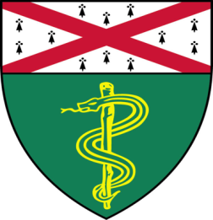

Giorgia Foggetti, PhD (Politi Lab)
Postdoctoral Associate

“Genetic Determinants of EGFR-Driven
Lung Cancer Growth and Therapeutic
Response In Vivo”

And

Huacui (Tracy) Chen, (Yan Lab)
Postgraduate Fellow
“Identification of Epigenetic Regulators in Breast Cancer Bone Metastasis”

Tuesday, December 10th, 2019
9:30 to 10:30 a.m.
TAC Auditorium, N-107, 300 Cedar Street

Coffee & refreshments beforehand- TAC Lobby

Questions? Wendy Folsom, Pathology: Wendy.Folsom@yale.edu, LH315, 785-3478

