Pediatric Pulmonology, Allergy,
Immunology & Sleep Medicine

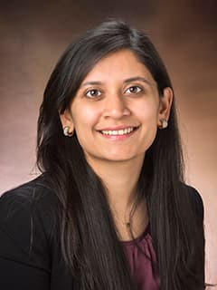
Saba Sheikh, MBBS MSCE
Assistant Professor, Department of Pediatrics, Division of Pulmonary and Sleep Medicine at Children's Hospital of Philadelphia, Buerger Center for Advanced Pediatric Care

The Relevance of Body Composition in People with Cystic Fibrosis
Friday, September 9, 2022
1:00pm-2:00pm
Trask Conference Room LMP 3108

