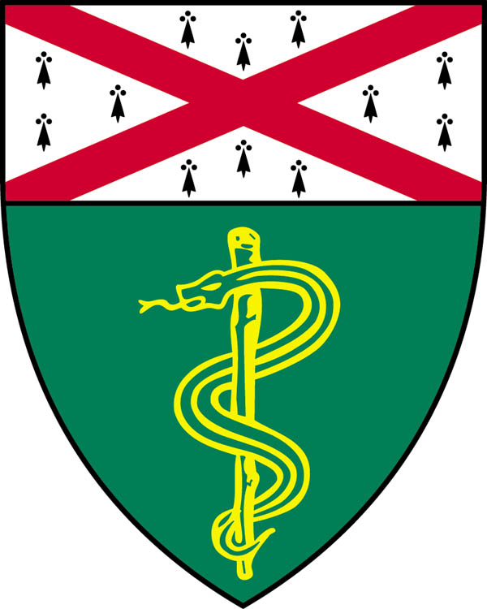
Yale Center for Molecular and Systems Metabolism (YMSM)

Ken Huaijin Loh
Assistant Professor

Department of Comparative Medicine

Yale School of Medicine, Yale University



“Brain-Body Interactions and how to find them”

Tuesday, December 6th, 2022
11:00-12:00
The Brady Auditorium
310 Cedar Street, B131
https://yale.zoom.us/j/91299591561
Contact Kristin.capuano@yale.edu for password

Hosted by: Tamas Horvath

Questions?
Kristin.capuano@yale.edu, 203-785-7118

