YALE SCHOOL OF MEDICINE
Department of Pathology

2020-21 Research in Progress Series

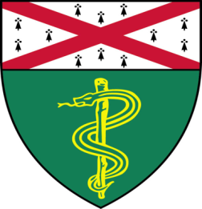
Xinbo Zhang, (Fernandez-Hernando Lab)
Associate Research Scientist

“Desmosterol Protects Against
Atherosclerosis Through LXR-Dependent
Inflammasome Inactivation”

And

Kiran Patel, (Nguyen Lab)
Postdoctoral Associate

“KDM2A Regulates an Adaptive
Transcriptional Response to Suppress
Ferroptosis in Metastatic Cells”

Join Zoom Meeting
https://zoom.us/j/95032258483
Passcode: 889918

Tuesday, December 8th, 9:30-10:30 a.m.

"All the contents are proprietary, unauthorized use of the information is prohibited and unethical".

Questions? Wendy Folsom, Pathology: Wendy.Folsom@yale.edu, LH315, 203-785-3478

