YALE SCHOOL OF MEDICINE
Department of Pathology

2021-22 Research in Progress Series

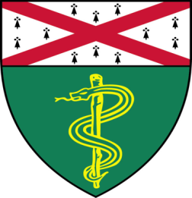

Ethan Lester, (Braddock Lab)
Post Graduate Associate

“Refining of Murine Models of CKD-MBD”

And
Taylor Takasugi, (Chang Lab)
M.D./Ph.D. Candidate

“POT1b and Telomere Length Maintenance”

Join Zoom Meeting
https://zoom.us/j/96247765777
Passcode: 889328

Tuesday, October 19th, 9:30-10:30 a.m.

"All the contents are proprietary, unauthorized use of the information is prohibited and unethical".

Questions? Wendy Folsom, Pathology: Wendy.Folsom@yale.edu, LH315, 203-785-3478

