YALE SCHOOL OF MEDICINE
Department of Pathology

2019-20 Research in Progress Series

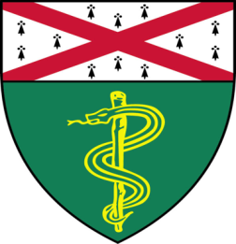

Michael Stankewich, Ph.D (Morrow Lab)
Associate Research Scientist

“The Spectrin Scaffold Forms and Maintains Membrane Domain Specialization”

And

Vesal Yaghoobi, (Rimm Lab)
Postdoctoral Associate
“Comparison of Tumor Microenvironmental Markers of African American vs Whites’ Triple “Negative Breast Cancer (TNBC)”

Tuesday, January 28th, 2020
9:30 to 10:30 a.m.
TAC Auditorium, N-107, 300 Cedar Street

Coffee & refreshments beforehand- TAC Lobby

Questions? Wendy Folsom, Pathology: Wendy.Folsom@yale.edu, LH315, 785-3478

