YALE SCHOOL OF MEDICINE
Department of Pathology

2021-22 Research in Progress Series

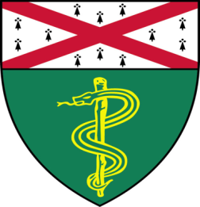

Robert Means, (Katz Lab)
Associate Research Scientist

“Exploration of the Biology of the
BCL-2 Family Member BOK”

Join Zoom Meeting

https://zoom.us/j/96247765777

Passcode: 889328

Tuesday, January 25th, 9:30-10:30 a.m.

"All the contents are proprietary, unauthorized use of the information is prohibited and unethical".

Questions? Wendy Folsom, Pathology: Wendy.Folsom@yale.edu, LH315, 203-785-3478

