YALE SCHOOL OF MEDICINE
Department of Pathology

2020-21 Research in Progress Series

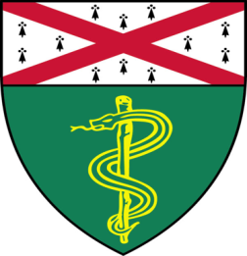
Colleen Lopez, Ph.D.(Qyang Lab)
Postdoctoral Fellow

“Immunoevasive Human Induced Pluripotent Stem Cells: The Promising Tools for Regenerative Medicine”

And

Sam Kerr, (Katz Lab)
Ph.D. Candidate

“Development of a Ligand CAR for Targeting T-Cell Leukemias and Lymphomas

Join Zoom Meeting
https://zoom.us/j/95032258483
Passcode: 889918

Tuesday, September 29th, 9:30-10:30 a.m.
"All the contents are proprietary, unauthorized use of the information is prohibited and unethical".

Questions? Wendy Folsom, Pathology: Wendy.Folsom@yale.edu, LH315, 203-785-3478

