Neurology Grand Rounds

Presented by
Yale School of Medicine, Department of Neurology

“Small Vessel Disease: Recent Clinical, Imaging and Mechanistic Insights”
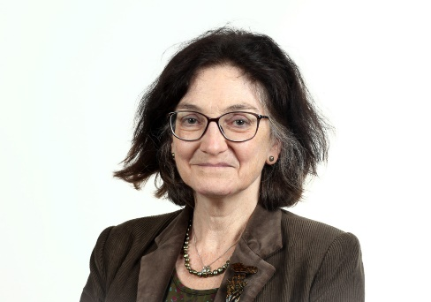
Joanna Wardlaw, CBE, MB ChB(Hons), MD, FRCR, FRCP, FMedSci, FRSE
Professor of Applied Neuroimaging;
Head of Neuroimaging Sciences; Director of Edinburgh Imaging;
Foundation Chair, UK Dementia Research Institute
University of Edinburgh
Date: Friday October 16, 2020 1:00pm
Location: https://zoom.us/j/96166169677?from=msft;

Course Director/Host: Joachim M. Baehring, MD
There is no corporate support for this activity
This course will fulfill the licensure requirement set forth by the State of Connecticut

ACCREDITATION
The Yale School of Medicine is accredited by the Accreditation Council for Continuing Medical Education to provide continuing medical education for physicians.

TARGET AUDIENCE
Attending Physicians, Housestaff/Fellows
Medical Students, Nurses, PA’s

NEEDS ASSESSMENT
Small vessel disease is poorly recognized; the symptoms associated with small vessel disease in particular that indicate worsening of brain injury are not well understood. Recent research indicates that small vessel disease lesions can relapse and remit. It also indicates ways in which small vessel disease may damage the brain beyond ischemia that have important implications for management, prevention, and treatment.

LEARNING OBJECTIVES
At the conclusion of this activity, participants will be able to:
1. Recognize symptoms associated with SVD.
2. Appreciate the variability of SVD lesions and their development or progression.
3. Understand that dysfunction of the small vessels can damage the brain through important mechanisms other than the typical ischemia associated with stroke.

DESIGNATION STATEMENT
The Yale School of Medicine designates this live activity for 1 AMA PRA Category 1 Credit(s)™. Physicians should only claim the credit commensurate with the extent of their participation in the activity.

FACULTY DISCLOSURES
Joanna Wardlaw, CBE, MB ChB(Hons), MD, FRCR, FRCP, FMedSci, FRSE – Diamedica (spouse/consultant), Phagenesis (spouse/consultant), Moleac (spouse/consultant).

Joachim M. Baehring, MD - None

It is the policy of Yale School of Medicine, Continuing Medical Education, to ensure balance, independence, objectivity and scientific rigor in all its educational programs. All faculty participating as speakers in these programs are required to disclose any relevant financial relationship(s) they (or spouse or partner) have with a commercial interest that benefits the individual in any financial amount that has occurred within the past 12 months; and the opportunity to affect the content of CME about the products of services of the commercial interests. The Center for Continuing Medical Education will ensure that any conflicts of interest are resolved before the education activity occurs.

