Yale School of Medicine and the Graduate School of Arts and Sciences
INVESTIGATIVE MEDICINE PROGRAM

INFORMATION
SESSIONS

Dates
Thurs. Sept. 17, 3-4 PM
Weds. Oct. 14, 3-4 PM
Thurs. Nov. 5, 4-5 PM
Mon. Nov. 16, 4-5 PM
Location: Email IMP@yale.edu for
Zoom information

Deadline
:
Application deadline is
January 1, 2020 for the 2020/2021 academic year.

Application deadline is January 1, 2021 for the
2021-2022 Academic Year

Eligibility

To be eligible for the program, applicants must have an M.D. or D.O. degree and completed two or more years of postgraduate clinical (residency or fellowship) training, and must currently (or by the time of IMP matriculation)
be a member of a residency or fellowship program at Yale, and be eligible to practice in the U.S.

The Investigative Medicine PhD Program will be holding informational sessions in which prospective candidates will have an opportunity to learn what the Program offers and speak with its directors. The IMP is a unique educational and training opportunity in clinical investigation for highly-selected physicians in clinical departments that leads to a PhD degree in Investigative Medicine through the Yale Graduate School of Arts and Sciences.
The goal of the program is to provide the training required to develop a broad knowledge base, analytical skill, creative thinking, and the hands-on experience demanded of clinical researchers
s:
7
5

7
devoted to either laboratory-based or clinically-based patient-oriented investigation. Students are provided with individualized training encompassing formal coursework and practical experience, under the supervision and mentorship of a senior faculty member and a graduate school Ph.D. thesis committee.
ty
,
f
)
f

.

For more information please contact IMP@yale.edu

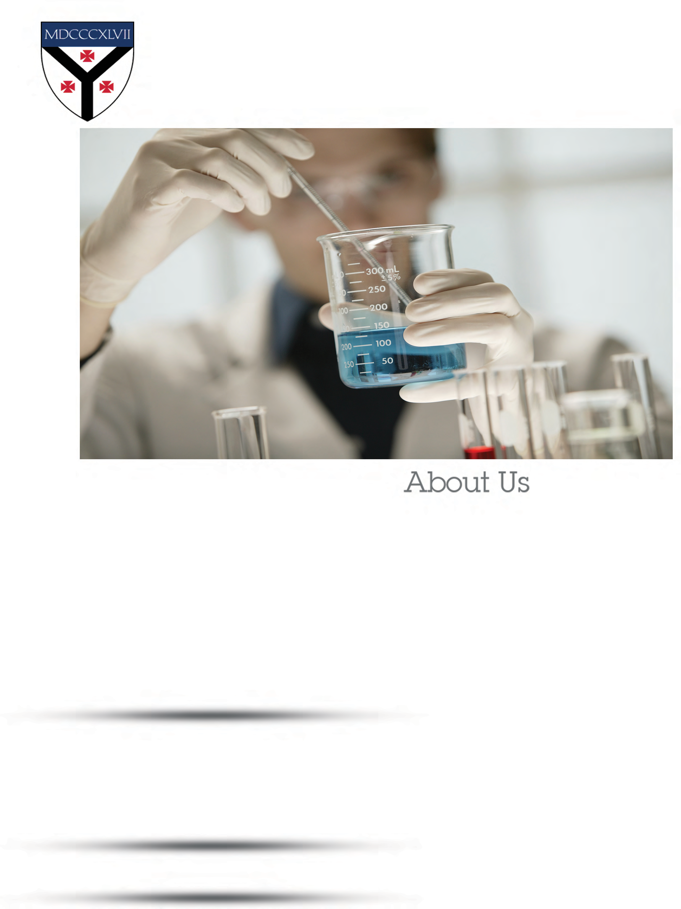

medicine.yale.edu/investigativemedicine

