YALE SCHOOL OF MEDICINE
Department of Pathology

2020-21 Research in Progress Series

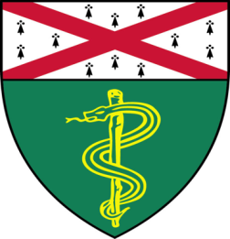
Michael Stankewich, Ph.D.(Morrow Lab)
Associate Research Scientist

“Age-Related Neurodegeneration Caused by a Spectrin Mutation that Alters its Calpain Processing”

And

Giorgia Foggetti,Ph.D.(Politi Lab)
Associate Research Scientist

“Genomic Mediators of TKI Sensitivity and Resistance in EGFR-Driven Lung Adenocarcinoma”

Join Zoom Meeting
https://zoom.us/j/95032258483
Passcode: 889918

Tuesday, January 26th, 9:30-10:30 a.m.

"All the contents are proprietary, unauthorized use of the information is prohibited and unethical".

Questions? Wendy Folsom, Pathology: Wendy.Folsom@yale.edu, LH315, 203-785-3478

