Yale General Internal Medicine Grand Rounds (GIM Grand Rounds)
Presented by
Yale School of Medicine’s Department of Internal Medicine
Section of General Internal Medicine

“PrEP-ing for the End of the HIV Epidemic”
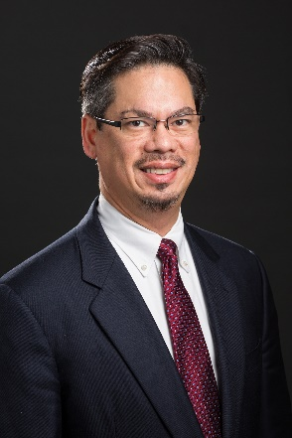
Michael Virata, MD, FACP
Associate Professor
Director HIV Clinical Services Int Med
Associate Professor Clinical Int Medicine
Yale Medicine

Date: January 27, 2022, 7:30 am - 8:30 am
Zoom: https://zoom.us/j/95341631860

Texting code for today’s session: 29066
Course Directors/Hosts: Lisa Puglisi, MD 203-784-7411 and Matt Ellman, MD
There is no corporate or commercial support for this activity

Program Goals:
- Understand the apporach to Ending the HIV Epidemic from the prevention perspective
- Provide an update on currently available prevention efforts and recent clinical trials
- Future of PrEP
Target Audience: Medical Professionals
Financial Disclosure Information: Dr. Virata reports the following relevant financial relationship(s) with ineligible companies: Advisor-Gilead|Membership on Advisory Committees or Review Panels, Board Membership, etc.-Janssen|Advisor-ViiV Pharmaceutical.
Dr. Ellman, Dr. Puglisi, and Dr. O’Connor, course directors and faculty members for the Yale General Internal Medicine Faculty Meetings, have no relevant financial relationship(s) with ineligible companies to disclose.
Patti Cavaliere, Vivian DuBrava, Michele Manganello coordinators/planners for the Yale General Internal Medicine Faculty Meetings, have no relevant financial relationship(s) with ineligible companies to disclose.
Accreditation Statement: Yale School of Medicine is accredited by the Accreditation Council for Continuing Medical Education (ACCME) to provide continuing medical education for physicians.
Designation Statement: Yale School of Medicine designates this Live Activity for a maximum of 1.00 AMA PRA Category 1 Credit(s)™. Physicians should only claim credit commensurate with the extent of their participation in the activity.

