Yale General Internal Medicine
Research in Progress Meeting

“Rethinking Housing, Health, and Homelessness”

James O’Connell, MD
Professor of Medicine, Harvard Medical School
President, Boston Health Care for
the Homeless Program
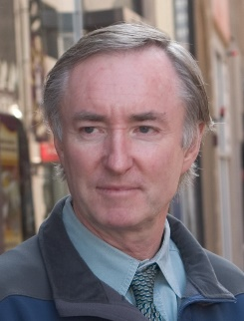
Date: Thursday, October 10, 2019
12:00pm – 1:00pm

Location: The Anlyan Center 2nd Floor
Room: TAC N203 (300 Cedar Street)

Yale General Internal Medicine Faculty Seminar
Course Director/Host: Patrick G. O’Connor, MD, MPH, 203-688-6532
There is no corporate or commercial support for this activity
This course will fulfill the licensure requirement set forth by the State of Connecticut

ACCREDITATION
The Yale School of Medicine is accredited by the Accreditation Council for Continuing Medical Education to provide continuing medical education for physicians.

TARGET AUDIENCE
Faculty, residents, students and staff involved in education of health care professional trainees.

NEEDS ASSESSMENT
There is an important need for general internists to understand the value of community level primary care assessment for policy and health planning, and the advantages of community-based participatory research methods for studying health systems.

LEARNING OBJECTIVES
At the conclusion of this activity, participants will be able to:
- Review the morbidity and mortality of those individuals who sleep on Boston’s streets.

- Share the experiences of a team-based model for the delivery of integrated medical and
psychiatric care in patient homes.

- Literature assessment: is housing health?

DESIGNATION STATEMENT
The Yale School of Medicine designates this live activity for 1 AMA PRA Category 1 Credit(s)™. Physicians should only claim the credit commensurate with the extent of their participation in the activity.

FACULTY DISCLOSURES
Dr. O’Connell has no conflicts of interest to disclose. Dr. Patrick G. O’Connor, Course Director, has no conflicts of interest to disclose.

It is the policy of Yale School of Medicine, Continuing Medical Education, to ensure balance, independence, objectivity and scientific rigor in all its educational programs. All faculty participating as speakers in these programs are required to disclose any relevant financial relationship(s) they (or spouse or partner) have with a commercial interest that benefits the individual in any financial amount that has occurred within the past 12 months; and the opportunity to affect the content of CME about the products or services of the commercial interests. The Center for Continuing Medical Education will ensure that any conflicts of interest are resolved before the educational activity occurs.

