Psychology Practicum in Eating/Weight Disorders
Yale University School of Medicine
The Department of Psychiatry at the Yale School of Medicine is seeking qualified candidates for psychology practicum opportunities in eating disorders and obesity. These positions are ideal for advanced graduate students in clinical/health/counseling psychology and will provide intensive training to individuals interested in careers in clinical practice and research in academic medical school and university settings.
These positions will provide intensive clinical training and on-going supervision by licensed psychologists in assessment (including diagnostic interviewing and structured interviews) and evidence-based behavioral interventions. These positions will increase competitiveness for top-tier psychology pre-doctoral clinical internships and for clinical-research and clinical-scholar careers.
Practicum students will participate in treatment studies for binge eating, disordered eating after bariatric surgery, obesity, and weight stigma. Students will work closely with faculty and other pre- and post-doctoral clinical-researchers in the Program for Obesity, Weight, and Eating Research (POWER) at Yale. Treatment studies test behavioral, cognitive-behavioral, pharmacologic, and combination treatments for adults and youth with binge eating and/or obesity, and multi-site longitudinal studies follow bariatric surgery patients. http://power.yale.edu and m.yale.edu/teenpower
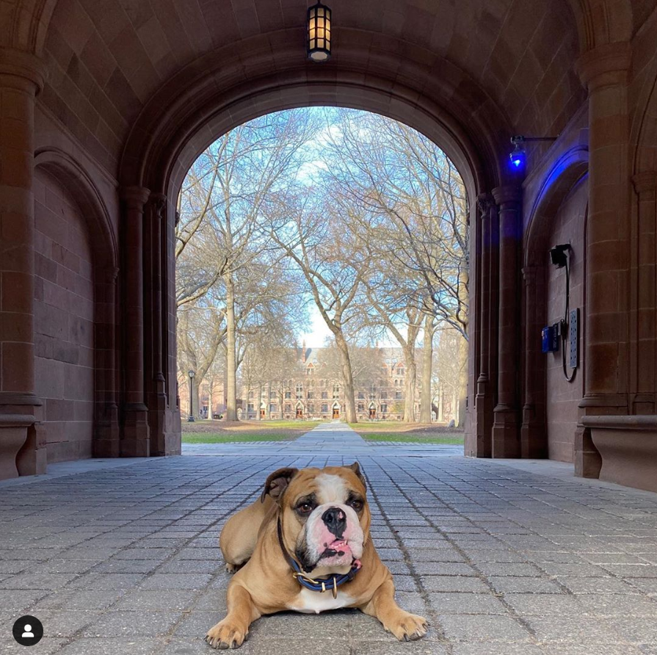
Practicum students must be enrolled in a doctoral program (PhD or PsyD) pursing a degree in clinical, health, or counseling psychology, and have either: (1) experience treating eating disorders or bariatric surgery patients (assessment, behavioral or cognitive-behavioral therapy), or (2) broader health psychology and behavioral medicine background plus interest in eating/weight disorders.
Start dates are flexible, ranging from June 2022 through September 2022, ending summer 2023.
Applicants are encouraged to apply prior to Dec 31 for full consideration, although applications will be reviewed on a continuing basis until positions are filled. To apply, please send a CV and statement of interest to Dr. Janet Lydecker (janet.lydecker@yale.edu).

