VIRTUAL SEMINAR
No Justice, No Peace: Moving Environmental Health Forward By Focusing on Environmental Injustice and Community Science
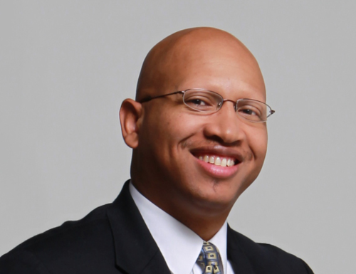
Sacoby Wilson, MS, PhD
Associate Professor
Maryland Institute for Applied Environmental Health
School of Public Health, University of Maryland
Dr. Wilson has over 15 years of experience as environmental health scientist in the areas of exposure science, environmental justice, environmental health disparities, community-based participatory research, water quality analysis, air pollution studies, built environment, industrial animal production, climate change, community resiliency, and sustainability. He works primarily in partnership with community-based organizations to study and address environmental justice and health issues and translate research to action. Dr. Wilson is Director of the Community Engagement, Environmental Justice and Health (CEEJH) Initiative. Through CEEJH, Dr. Wilson is engaging communities in the Washington, DC region on environmental health issues. He has worked on environmental justice issues including environmental racism with community-based organizations through long-term community-university environmental health and justice partnerships in South Carolina and North Carolina. Dr. Wilson has been very active professionally as an environmental justice advocate. He is Founder of 17 for Peace and Justice and a Co-Founder of the DC/Maryland/Virginia (DMV) Environmental Justice Coalition. He is a member of the USEPA’s National Environmental Justice Advisory Council (NEJAC), a past Chair of the APHA Environment Section, on the Board of Community-Campus Partnerships for Health, a former member of the Board of Scientific Counselors for the CDC NCEH/ATSDR, and former Chair of the Alpha Goes Green Initiative, Alpha Phi Alpha Fraternity, Inc. He is also a senior fellow in the Environmental Leadership Program. Dr. Wilson, a two-time EPA STAR fellow, EPA MAI fellow, Udall Scholar, NASA Space Scholar, and Thurgood Marshall Scholar, received his BS degree in Biology/Ecotoxicology with a minor in Environmental Science from Alabama Agricultural and Mechanical University in 1998. He received training in environmental health in the Department of Environmental Sciences and Engineering, at the University of North Carolina at Chapel Hill. Dr. Wilson received his MS degree in 2000 from UNC-Chapel Hill and his PhD from UNC-Chapel Hill in 2005.
12-1 p.m. EST. Wednesday, February 2, 2022
Zoom link: https://yale.zoom.us/j/92965470385

