YALE SCHOOL OF MEDICINE
Department of Pathology

2021-22 Research in Progress Series

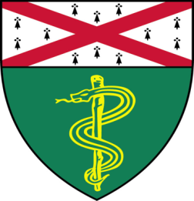

Xiangyu Ge, (Muzumdar Lab)
Ph.D. Candidate

“Uncovering the Resistance Mechanisms of KRAS Inhibition in PDAC”

And
Shanin Chowdhury, (Vilarinno Lab)
M.D./Ph.D. Candidate

“Investigating The Extrinsic Cues That Maintain Gimap5 Activity and Liver
Endothelial Cell Homeostasis”

Join Zoom Meeting
https://zoom.us/j/96247765777
Passcode: 889328
Tuesday, October 26th, 9:30-10:30 a.m.
"All the contents are proprietary, unauthorized use of the information is prohibited and unethical".

Questions? Wendy Folsom, Pathology: Wendy.Folsom@yale.edu, LH315, 203-785-3478

