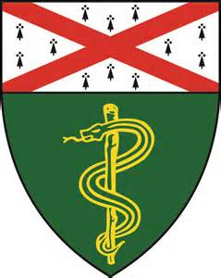
Palliative Care Conference
Tuesday, January 21st @ 4pm
Fitkin (FMP) 6th Floor, Conference Rm 618
(see bottom of flyer for directions)
4-6:00pm

Journal Club Presentation

Presenter: Alex Mbewe, MD
YNHH Hospice & Palliative Medicine Fellow
Title: “Pain in Older Adults, Beers Criteria,
and Rehospitalization”

Palliative Case Conference

Presenter: Tracy Shamas, MSN, APRN, ACHPN
Palliative Care Coordinator, VA Connecticut
Title: “A Case For Palliative Sedation”

Directions to Fitkin (FMP) Room F-618 Conference Room
Take elevator to 6th floor. Exit elevator and take u-turn to the right. You will see a closed glass door with “Psychological Medicine Service and Interpreter Services” sign. The glass door is unlocked – enter and look for F-618 down hall on the left. Light Refreshments Served

Please contact Lisa.Arnel@yale.edu for additional information

